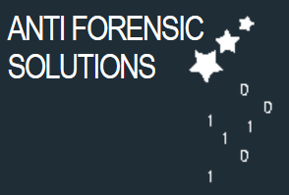

**Anti-Forensics Solutions**

Dale Stubbs, Jack Yates, Asahd Mahmood, Ryan Malaney, Joseph Telford, Adam Morrison, Andrew Slater, Collins Nyange, Hamza Pervaiz and Krystian Trzcionkowski

Anti-Forensics Solutions

Majdi Friday - Group A.

# **Executive Summary**

# **[Dale Stubbs]**

The high street computer shop can be a very useful place to visit on occasions when something goes wrong that you can’t fix by yourself. This can be an expensive solution to the issues you may face especially if the problems keep occurring, Enter Anti-Forensics Solutions.

We are a ‘high street’ style Anti-Forensics shop based entirely online. This eliminates the requirement for you to remove your PC or laptop from where it’s situated which also eliminates the potential for damage to your hard drive.

We offer a wide range of tools for our customers that range from Password unlocking tools and Encryption key recovery to Wireshark, Network security assessment tool, Network monitor and Packet sniffers.

We distribute all of our tools on bootable pen drives via the UK Postal Service. This means that once you’ve bought the tool you own the tool and can use it as much as is required.

All of our tools were originally open source tools and therefore have not cost us a thing, eliminating the dreaded overheads of hiring multiple programmers with specialist expertise. As the tools are open source we needed to ensure that all legal channels were followed before creation of the tools.

**Contents**

Executive Summary [Dale Stubbs] 1

1. Introduction [Jack Yates] 1

1.1 Team Members 1

1.2 Aims and Objectives of AFS 1

1.3 Sub Projects 1

1.4 Context of the Market 1

1.5 Timescales 1

1.6 How a Profit is to be made 1

In the next chapter: 1

2 Marketing [Ashad Mahmood] 1

2.1 Our Company, Our Vision 1

2.2 Market Evaluation 1

2.2.1 S.W.O.T Analysis 1

2.3 Marketing Strategy 1

2.4 Advertising 1

2.4.1 Website 1

2.4.2 Social Media – Facebook, Google+, Instagram, Forum Boards, YouTube 1

2.4.4 Billboard and Newspaper 1

2.5.1 Introduction to the event 1

2.5 Launch Event 1

2.5.2 Why are we having a launch event? 1

2.5.3 Target Audience 1

2.5.4 Agenda 1

2.5.5 Location 1

2.5.6 Costs 1

2.6 The Future of AFS 1

In the next chapter: 1

3 Sub-Project – Packages 1, 2 and 3 [Andrew Slater] 1

3.1 Product aim 1

3.2 Research 1

3.3 Software 1

3.3.1 Package 1 (Password Recovery) 1

3.3.2 Package 2 (Data Recovery) 1

3.3.3 Package 3 (PC Optimisation) 1

3.4 Job role 1

3.5 Product overview 1

3.6 Summary 1

In the next chapter: 1

4 Sub-Project – Packages 4, 5 and 6 [Joseph Telford] 1

4.1 Product aim 1

4.2 Research 1

4.2.1 Receiving program list 1

4.3 Software 1

4.3.1 Original 1

4.3.2 Update after problems 1

4.4 Job role 1

4.5 Product overview 1

4.6 Costing 1

4.6.1 Software 1

4.6.2 Labour 1

4.6.3 Packages 1

In the next chapter: 1

5 Sub-Project – Written Instruction Development [Hamza Pervaiz] 1

5.1 Introduction 1

5.2 Overview 1

5.3 Development 1

5.4 Aims 1

In the next chapter: 1

6 Sub-Project – Video Instruction Development [Krystian Trzcionkowski] 1

6.1 Introduction 1

6.2 Overview 1

6.3 Development 1

6.3.1 Designing and recording 1

6.3.2 Editing 1

6.4 Aims 1

6.4.1 What could be improved? 1

In the next chapter: 1

7 Sub-Project – Website Development [Adam Morrison] 1

7.1 Introduction 1

7.2 Sub Project Aims & Objectives 1

7.2.1 Key Aims & Objectives 1

7.2.2 Websites functional needs 1

7.3 Web Development Research 1

7.3.1 Design 1

7.3.2 Development Process 1

7.3.3 Technical Requirements 1

7.3.4 Legalities 1

7.3.5 Online Deployment 1

7.4 Web Development Outcome 1

7.4.1 Website Design Outcomes 1

7.4.2 Logo Design Outcomes 1

7.4.3 Finished Product 1

7.5 Problems & Solutions 1

7.5.1 Problems & Solutions 1

7.6 Future development and plans 1

7.6.1 Google Analytics 1

7.6.2 Google and Facebook Login 1

7.6.3 SSL Certificate 1

7.6.4 PayPal 1

7.6.5 Domain Name Registration 1

7.7 Justification of resources used to host & develop the website 1

7.6.1 Host Provider 1

7.6.1 Technologies 1

7.8 Sources of Information 1

In the next chapter: 1

8 Sub-Project – Advertising and Social Media [Collins Nyange] 1

8.1 Introduction 1

8.2 Sub Project Aims & Objectives 1

8.3 Advertising Research 1

8.4 Social Media Research 1

8.5 Problems & Solutions 1

In the next chapter: 1

9 Finance [Ryan Malaney] 1

9.1 Initial Expenditure 1

9.2 Marketing 1

9.3 Wages 1

9.4 Projections & Sales 1

In the next chapter: 1

10 Project Review and Analysis (Conclusion) [Dale Stubbs] 1

10.1 Project Strengths 1

10.1.1 Cohesiveness 1

10.1.2 Communication 1

10.1.3 Time Management 1

10.2 Project Weaknesses 1

10.2.1 Attendance 1

10.2.2 Deficiency of Knowledge 1

10.3.1 Student Email 1

10.3 Communication Analysis 1

10.3.2 University Moodle 1

10.3.3 Team Meetings 1

10.3.4 Google Drive 1

10.4.1 Tasks Completed 1

10.4 Responsibilities Maintained 1

10.4.2 Deadlines Met 1

10.5 Overall Conclusion 1

Bibliography 1

Appendices 1

# **1. Introduction** **[Jack Yates]**

Welcome to the final project report of Anti Forensic Solutions (Madji Friday AM Group A) hereby referenced to as AFS. In this chapter I will discuss the following topics:

* Team Members
* Aims and Objectives of AFS
* Sub-projects
* Context of the Market
* Timescales
* How a profit is to be made

## **1.1 Team Members**

We have member of the group who all contributed to the project. Upon creation of the group everyone was assigned a specific role within the team.

**Leader** – Dale Stubbs

**Deputy Leader** – Jack Yates

**Finance Director** – Ryan Malaney

**Marketing** – Asahd Mahmood

**Sub-Project 1** – Joseph Telford

**Sub-Project 2** – Andrew Slater

**Sub-Project 3** – Hamza Pervaiz

**Sub-Project 4** – Krystian Trzcionkowski

**Sub-Project 5** – Adam Morrison

**Sub-Project 6** – Collins Nyange

## **1.2 Aims and Objectives of AFS**

Since all the members of our group are currently taking the Computer Forensics and Analysis course, it was decided that the main aim for this project was to develop a product that would directly relate to the forensics unit. Despite this narrowing down our options to some degree, we still had a huge variety of potential ideas that we could use for our project. During the initial start-up period of the project we first thought of creating an online learning tool, app and interactive program which would teach customers how to use various programs that are used for analysing computers. However after discussing this idea we found that, since we were just beginning our Computer Forensics and Analysis unit, we did not have enough knowledge in that field to create a learning tool that we would all feel proud of. As a result, we came together and collectively decided to change the idea to a something that we would be capable of doing to the standard expected of us.

Our final objective ended up being:

* To create a ‘High Street’ style online Computer Forensics shop that would allow customers to reduce the time and cost that are usually present when sending their computer off for repair.

## **1.3 Sub Projects**

After research had been completed and we had scrapped the idea of an online learning platform. We decided on six sub-projects. These projects would cover every aspect of our business from the creation of the packages, to the building of our marketing campaign. Once we had decided on the sub-projects, the group members who had been assigned to sub-projects were asked which task they would prefer. In places that there was two or more people wanting to do a specific task a vote was cast after hearing why each person would be best suited for a specific task. Eventually we decided on the assigned sub-projects below:

* Website Creation – Adam Morrison
* Written ‘How to’ guides for each product – Hamza Pervaiz
* Video ‘How to’ guides – Krystian Trzcionkowski
* Creation of packages 1,2,3 – Andrew Slater
* Creation of packages 4,5,6 – Joseph Telford
* Creation of Advertisements and social media pages – Collins Nyange

## **1.4 Context of the Market**

Once we had decided what our companies product would be we began researching the market surround similar items that are already available. We found that despite numerous open source and purchasable pieces of software available on the website, there was very few software packages like ours that could be purchased both in stores such as PC World or online. As a direct result it was discovered that there would be little competition from other competitors, this would mean that we could raise our product’s prices slightly. In addition to this we also completed some trend analysis, this showed us that the modern society is becoming more and more dependent on technology such as computers and, in some cases, sending off their PC isn’t a viable option. Because of these reasons, we decided to main our products at 2 main markets, people with little computing knowledge who require services such as password recovery but don’t have the knowledge to do so. Our second target audience was customers who have some knowledge of computing and want numerous tools that they can use to both further this knowledge and, if they desired, make adjustments to the tools. Our product can service both these target audiences whilst still offering a high level of service.

We had from November to March to develop this project so we set numerous deadlines rather early on to ensure that work would be completed on time. However we did not take into consideration the fact that group members may have been absent or un-cooperative. We decided to set rather strict deadlines when organising the tasks as we didn’t want to fall behind and leave the project unfinished or finished with a much lower quality then we were capable of. Dale and I created a Gantt chart [Figure 1.1] that would help show us what needed to be done for what date, how much workload group members would be under and what tasks would need to be completed before others could be started.

## **1.5 Timescales**

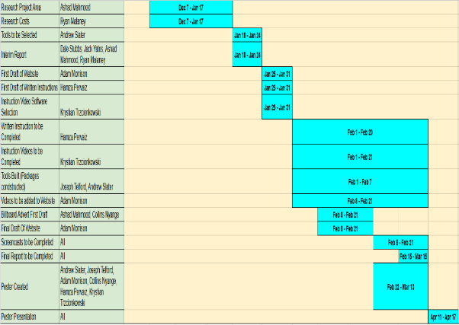This helped everyone visualise where the project should be and where we should be up to. We began working on the Gantt chart on the 10th January because it was at that point that we decided to switch from the online learning program the AFS.

*Figure 1.1 The Gantt Chart*

We held meetings every few weeks to discuss the progress that was being made on the project and to solve any problems that required the entire involvement of the group. There were times were we would either not meet up or people would be absent from the group meetings due to a number of reasons, the forums were used during these times to ensure that everyone was informed on the current affairs.

## **1.6 How a Profit is to be made**

We established that our product would start generating revenue upon launch, however the amount generated would not cover the start-up costs and would rely heavily on our advertising campaigns and online presence. We envisioned selling around 1000 USB drives with our packages on within the first year with the vision of increasing this number to around 15,000 in the second year. As we would be purchasing the USB drives in bulk, we would pay a smaller price than the usual consumer. In addition to this the cost of purchasing envelopes and delivering the drives to customers would be rather small. This low production and delivery cost would ensure that we could make a profit on each individual pen drive sold. This profit would grow as the years progressed and more customers purchased our product.

## **In the next chapter:**

In the next chapter, our marketing director Asahd Mahmood will go into more depth about how we are going to market our product. He will provide information on our advertising strategies, the current market situation and where our company resides within this. Also, he will discuss details regarding the launch day and our plans for it.

# **2 Marketing**

# **[Ashad Mahmood]**

In this chapter I will discuss the following topics:

* Our Company, Our Vision
* Market Evaluation
* Marketing Strategy
* Advertising
* Launch Event
* The Future of AFS

## **2.1 Our Company, Our Vision**

In this chapter, I will talk about the role I played to aid with the development and production of Ant-Forensics solutions and the products we offer. I will discuss the research I have found and how that research will play a key role to the development of AFS

The team behind AFS have the purpose and determination to bring the knowledge involved behind forensic computer defence to the everyday computer user. We want to bring the ability to defend yourself to the public. Our company wants to fill the current gap we have found and bring an industry standard market to this area of computing. Anti-Forensics solutions have the goal and determination to be a company that will provide the everyday computer user with the ability and knowledge to defend themselves from vulnerabilities and potential privacy breeches that lay within their digital footprint, most of which they don’t know exist.

## **2.2 Market Evaluation**

Before completing the development of this product, research had been conducted on our products background area, by the research director Asahd. Through research, we had found that anti-forensic tools were out there available online available for public download by anyone. The problem with this was that we had found that the majority of users where confused on how to use different tools as they were requesting guides on how they work and some users where asking what tools can be used for tasks that they need completing. We had found that online forum boards where the primary source of providing information for people to access and find these tools. In addition to this we found that these tools where being used and requested daily, but the accessibility to them and the usage of them was limited to the people with knowledge on working with the tools as most forum boards are tight knit communities. We had found that the majority of users and potential customers where people sticking to forum boards asking for tips and tricks on what tools they could use for tasks we can offer solutions too, for example people would ask on how they could recover deleted files.

(<http://www.tomshardware.co.uk/forum/215655-46-where-deleted-file-network-share-drive>)

With this information, we had recognised that there was a gap in the market surrounding the area of Anti Forensic tools, so as a company we made the decision to capitalize on this gap. We had realised that we could fill and bring a market to an area which has been overlooked and avoided.

We had found that different tools were available to the public for purchase or for open source downloads, however they were scattered around on different sites, some foreign sites and a lot didn’t provide that trustworthy and professional feel. They were hard to find and presented in a format that was un-useable to the average consumer requiring a decent level of technical understanding, for example the tool on windows called jhead, which allows a person to access exif data in an image. The tool only works via the command prompt and provides no GUI making it difficult for most to use.

There are products available which group tools together but they do not meet certain criteria and offer a professional experience to a customer like we want to offer to the general public. For example the hirens boot cd, this is a product that offers different utilities, but they are out of date and is provided on a CD. They also don’t allow direct downloads from their site, they link you to other sites, some of which bring up a potential virus threat.

Based on further research, we had predicted that our product would fill this gap and create a market which offers a unique variety of tool packages that would be available to the general consumer and thus enable a new found edge to one’s personal privacy requirements. We took the benefits of open source tools already available for use, we then handpicked each tool to complete the package description.

We looked at the current negatives in the market, such as people implementing viruses into tools. Through this, we had made our product stronger by thoroughly searching each tool. In addition to this, extensive research was conducted in order to determine the best tools that could be grouped up that were not already available as a package or in a usable format to the general public. From this, our product had been created.

### **2.2.1 S.W.O.T Analysis**

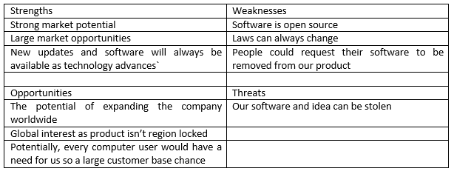

*Figure 2.1 SWOT Analysis*

## **2.3 Marketing Strategy**

Our marketing strategy will consist of us providing our clients with the reassurance that we will be able to fulfil their needs and support them with our guides and tutorials. We are keen on directing a user to the correct product they will require based on the needs they have. With our company, AFS being one of the first in this market area, we have the intentions of undertaking wide-ranging advertising techniques. Due to the nature of the product, we will mainly focus on online advertising creating a name for ourselves within the online communities on forum boards etc. We will also incorporate traditional advertising methods, keeping it within the monthly budget.

With the marketing strategy devised, we were able to decide on how we intended to sell our product and create an image of it. We decided to package the tools and distribute them on to usb sticks for reasons verified by research, feasibility, and cost efficiency. We had looked at similar past products and the way different ones had been completed and distributed. Some products had been sold on CD’s and others where available for direct download. We decided not to pursue any of these methods for distribution as CD’S have become obsolete since a lot of devices don’t have cd drives any more. Also they aren’t as efficient when being used in a live environment. Although direct downloads are a faster, easier and more cost efficient method of packing a product, they aren’t as efficient for use and come with a great safety risk. There would be risks with offering direct downloads for our product, other websites could acquire the packages and re distribute them, but with malicious intent. USB sticks seemed like the most efficient method of distributing our packages because it would make them more efficient to use and offer a better sense of security for consumers as they would have knowledge that the product is coming from a trustworthy company.

Playing a crucial role to the development and growth of our product, advertising will be something that we will have to take a great planned approach to. When developing and creating our product, one of the most important aspects of advertising is planning on how we will market the product to our customers.

## **2.4 Advertising**

We completed extensive research on methods we believed could be most beneficial for getting our product out there and established. After numerous group decisions, based on evidence provided by the marketing and research director. AFSs decided to focus on taking the social media approach for marketing our product and spending the majority of the budget there, with the exceptions of some traditional advertisements such as a billboard and a newspaper advert.

We found that with our product being aimed mostly at the more technically literate users, they are more likely to discover the product if it is advertised online on sites such as Facebook, Twitter, Instagram and different websites. Alongside this, we are using a traditional marketing method which is using a billboard. This is a useful method since we will be able to advertise to the general public.

As advertisements are a big factor to the sales for our product, a £4000 monthly budget has been allocated for advertising.

### **2.4.1 Website**

Just like the majority of companies in current times, we will feature a website as a part of our business. Developed by our web department, which is a sub project being led by Adam Morrison. The web site will be used to present what the company stands for and the services we offer; it will include in depth descriptions of all available packages for our customers to read. For AFS, the website will play a bigger part than just advertising our product, as we will also include written and video guides on how to use each individual tool which is part of the service we offer.

### **2.4.2 Social Media – Facebook, Google+, Instagram, Forum Boards, YouTube**

Due to the nature of our product, building an online presence is very ideal as our company intends to have a lot of online customers. One of the ways in which we intend to build this online presence is through social media as social media users are the type of people AFS wants to bring knowledge too. With the nature of how social media works, we will be to spread our product making It reach a lot of potential customers. All of the social media services we intent to use are free except Facebook. With Facebook, a company has the option to make their page a sponsored advertisement.

*Figure 2.2 Social Media Advertising Cost*

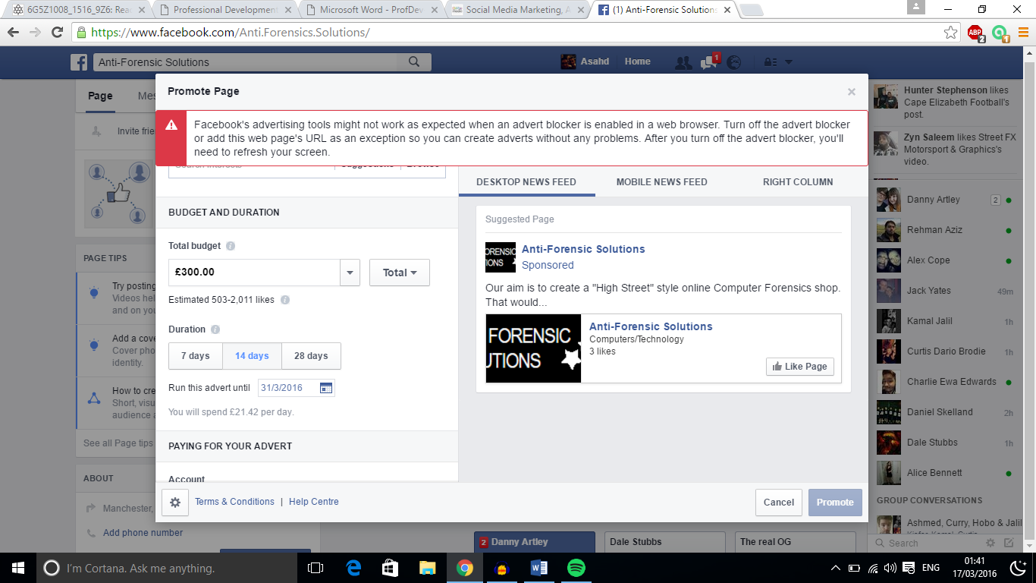If you look at [Figure 2.2], you will be able to see that if we were to spend £300, we would be able to reach an estimated amount of 503 – 2011 people over a 14-day period. With Facebook we, as a new company will have the option to display our product to people that are interested in viewing new technology and people interested in forensic computing.

**2.4.3 Tech Bloggers**

Another method of advertising which we believe will be greatly beneficial to our company will be to offer the chance for bloggers and technology reviewers a chance to get a hands on experience of what our product offers. After this, they will have the chance to review the product on their site. This is greatly beneficial to both parties as it allows us to reach their fan base, while giving them a chance to breach a new market for reviewing.

### **2.4.4 Billboard and Newspaper**

As well as aiming to generate a big online presence, Anti forensics solutions still intends to pursue some traditional advertising methods such as a billboard and a newspaper. Weill place an advert on a billboard placed outside the Piccadilly train station, we have decided to use this billboard because we believe that it will be seen by a lot of people as Manchester Piccadilly is one of the business train stations in the UK.

*Figure 2.3 Available Billboard Locations*

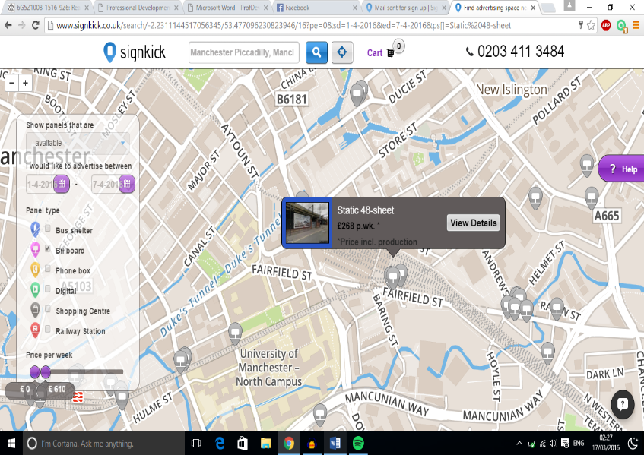If you look at [Figure 2.3], you will be able to see billboards that are available for advertising on through signkick. The location I have selected in [Figure 2], is placed directly outside the Piccadilly train station and it will cost us £268 for the first week of advertising on this billboard. In this cost, printing and labour is included.

Another method of traditional advertising, which has an estimated number of 5,178,00 readers daily is by using a Newspaper slot, more specifically a slot on The Sun newspaper. Advertising on a small spot here, will cost £77 a day. On launch week, we plan on advertising every 2 days for 7 days. This will cost us £539.

*Figure 2.4 Breakdown of Advertising Costs*

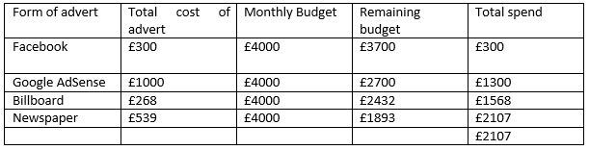

Currently we are left with £2107 of the monthly budget for advertising, as time goes on more money will be spent on advertisements that prove to be useful. [See Figure 2.4]

## **2.5.1 Introduction to the event**

## **2.5 Launch Event**

As with a lot of newly released products, AFS had decided to follow the global trend and host a launch event which will showcase our product. The aim of this launch event will be to promote our company and the products we will be creating and selling. The event will be aimed for the end of third term of education times, as that will be when a lot of people are free and students will be stress free and able to attend. We will host the launch event as an open event, where anyone will be able to attend with or without an invite.

## **2.5.2 Why are we having a launch event?**

The purpose of this event will be to showcase our product and prove to the customers that there is a need for AFS to tackle issues they more than likely didn’t even know existed. To prove to the customers that what our company will offer is real, we will hold live demonstration’s on machines setup with scenarios in which our devices are created for. On top of this, we will allow people to bring in their own laptops for us to show that our product works and that there is a need for it.

The launch event will also serve a purpose of allowing customers to meet the team behind the product and allow us to build a customer relationship.

## **2.5.3 Target Audience**

At our launch event, we will initially target our invites towards local businesses and companies that could benefit from using our product and selling our product. We will invite local stores that sell different types of technology such as mobile phone repair stores, computer repair store’s and local big chain business such as inviting the manager of Manchester’s curry’s & PC world. We will then target smaller audiences such as individual users, these will be people of the general public. We will target adverts to these people through social media pages, and inviting forum board communities.

An additional note for the target audience, due to the location of the launch event (The university of Manchester) we are hoping that students and staff will also attend our open event.

## **2.5.4 Agenda**

When hosting a launch event, it is crucial to have a scheduled event. Each task must be completed down to the minute, as well as this each member must present themselves with a professional manner as this will represent the company.

* 10:00am – 10:30am – Arrival – Upon the arrival of our guests, we will stand near the entrance and around the venue having informal greetings with visitors and answering any questions they may have about the day. Tea, coffee and biscuits will be available.
* 10:30am – 11:00am - Welcome and introductions to the company – This speech will be given by the team leader, he will talk about the team member’s backgrounds and what drove us to creating this product etc.
* 11:00am– 12:00pm – Introduction to the product- This is a speech to be given by the deputy leader, he will talk about the product and the power behind it
* 12:00pm – 1:00pm – Lunch – Buffet style
* 1:00pm – 1:30pm – Marketing will present his research found supporting the development of the product and will explain his role within the company
* 1:30pm – 2:00pm - Finance will present the costing of the product, projected profits and explain his role within the company
* 2:00pm – 3:00pm – A live demonstration of each package being used
* 3:00pm – 3:30pm – Live demonstration’s will be performed on the devise of visitors
* 3:30pm – 4:00pm – closing speech by the team leader and a summary of the event
* 4:00pm – 4:20pm – Questions and answers
* 4:00pm – 6:00pm – Informal chats till the venue hire time ends, talk about potential sales.

## **2.5.5 Location**

AFS has decided to use university place as its location for the launch event. This is a hall located inside the University of Manchester. This will be an ideal location for Anti forensics solutions and the customers as their will be a lot of support from the staff members regarding the location and technical issues. The location is ideal as it is reachable via public transport.

The venue comes included with standard equipment such as a data projector, pa, projection screen, network point and presenting computer, all of which are included in the booking price. The venue can house up to 1000 people.

## **2.5.6 Costs**

*Figure 2.5 Breakdown of Launch Event Costs*

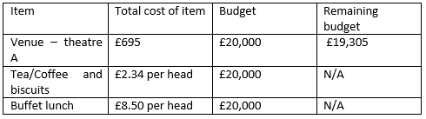

Figure 2.5 shows a full breakdown of our costs for organising and fulfilling a Launch Event for our products.

## **2.6 The Future of AFS**

As technology advances on a daily basis, the way in which our product works could always change. The members at Anti-Forensics solutions will always be on top of current technology changes and as the marketing and research director, it will be my job to keep a constant eye on the market looking out for competitors and changes within the laws that could affect us.

## **In the next chapter:**

In the next chapter, my college Andrew Slater will discuss the tools used, how they work, the choices behind selecting them and the manufacturing of packages 1, 2 and 3.

# **3 Sub-Project – Packages 1, 2 and 3**

# **[Andrew Slater]**

In this chapter I will discuss the following topics:

* Product aim
* Research
* Software
* Job role
* Product overview

## **3.1 Product aim**

The overall aim of the product is to create multiple sets of tools designed to give the average, less tech savvy user, a means to get the most out of their system without needing to do their own research and be readily available from the get go. Fundamentally, our product is purely plug in and play.

## **3.2 Research**

For this section of the report, I will be discussing the research I conducted to attain the software which would make up the bulk of our product. This is arguably the most important aspect of the task I was set as without a suitable investigation of the tools, then we could potentially be selling a defunct creation to our user-base. This would be harmful to the company, and its employee’s, reputation, both short and long-term.

To be sure that I attained the best possible software tools to fit their labelled needs, I had to conduct a proper and thorough research. To do this I scoured the internet for numerous articles about the section of anti-forensics they come under and managed to obtain the best possible tools based on the recommendation of established technology writers and experts.

When performing the research for package 1, I came across an article on the reputable site known as TechRepublic (I have included a link too said article below). From this article I have been able to extrapolate what are deemed the best and most trustworthy password recovery tools, they even provided images which gives you a clearer idea of how each program works. Once I had chosen the programs for this package, I then set out to downloading each program and inserting them all into a compressed .zip file name “Package1” so it could be ready to place onto a pen-drive and prepared for sale.

[*http://www.techrepublic.com/blog/five-apps/five-trustworthy-password-recovery-tools/*](http://www.techrepublic.com/blog/five-apps/five-trustworthy-password-recovery-tools/)

As with package 1, carrying out research for package 2 underwent a similar process; searching the internet for viable and reputable tech news outlets, however, I did have some slight trouble collecting information for this part of the product as there was not much in the way of easily available, easy to read information discussing open source lost data-recovery tools so I decided to use a different approach to gather my research data. I asked on a vastly populated discussion forum for a popular technology website, known as Tom’s Hardware, what they would deem to be the best open-source software for this particular area. They delivered many responses and helped in my search a great deal.

Package 3 (optimisation) did not garner as much trouble for me as package 2 did as open source optimisation tools are more plentiful than product key recovery software. The research I did here involve looking at the more well-known optimisation tools that the more tech savvy person will already know about, and search for the best open source alternatives which would be feasible for us to use within our product.

## **3.3 Software**

This section of the report is about the software tools themselves. This will be about what the tools actually accomplish plus an explanation about of some of the technicalities about what they are intended to carry out.

## **3.3.1 Package 1 (Password Recovery)**

**jPassword Recovery Tool**

Jpassword is an incredibly lightweight tool designed to help the user recover the password for any password protected archive file. This tool may also require additional archiving software such as “WinRAR” or “7zip”.

**OPHCrack Live- Windows Account Password Recovery**

OPHCrack is an application designed to crack Windows passwords. It does this via a method called LM hash cracking.

LM hash cracking is an encryption function intended to store away password hashes in windows. It is somewhat outdated but is still seen in use on local and domain hashes. LM hash will split the password into two segments and each individual segment can go up to seven characters, if the password is not seven characters long then the second section will just simply be a blank hash. The LM hashing method used by OPHCrack is known as “rainbow tables”. The program creates a table consisting of passwords and hash combinations. It then looks up the halves of all the hashes and once it has examined them all, brute forces its way through the password.

**Hash Suite**

Hash Suite is a program intended to assess the safety and security of password hashes. Hash Suite creates many different passwords and as they are inputted into the program, hashes them and matches the hashes with hashes which have been stored. This method seemingly works as people tend to create passwords for themselves which are simple to break. Additionally, Windows operates in a way that its hash function are extremely quick to compute, particularly if your password is attacked.

## **3.3.2 Package 2 (Data Recovery)**

**Lazesoft Windows Key Finder**

This is a very basic and lightweight program. The intention of this program is to assist you should you misplace the product key for your version of Windows or Microsoft Office. It will reacquire said product key for you and copy it to your clipboard, allowing you to simply paste it in giving you full access to your copy of Windows or Microsoft Office again.

**Recuva Undelete Software**

Recuva is a software application created to restore files which have been erased, whether accidentally or maliciously. It is able to bring back files from an emptied recycle bin, or even files from external devices like music or photos which were initially saved on a digital camera.

**Test Disk - Partition Recovery**

Similar to Recuva, test disk is designed to recover lost data. However, its method is somewhat different. Test disks purpose is to reinstate previously lost partitions. It also contains many other useful features such as repairing a previously defunct boot-up disk or something more complex like rebuilding an NTFS boot sector.

**AIRCRACK**

AIRCRACK is a very useful suite of tools dedicated to evaluating your WiFi network’s security. Its array of tools concentrates on four different areas of network security.

* Monitoring: Watches all packets apprehended and observes any data that is exported in a text format for further evaluation.
* Attacks: The software will replicate an attack allowing you to see how your network was penetrated. Prevents any de-authentication (which is when a legitimate user has been removed from the network).
* Testing: This is essentially just a benchmark test for your Wi-Fi cards and the capabilities of your drivers.
* Cracking: Again if you have misplaced or simply forgotten your Wi-Fi key (WPA/WPA2) this program has the ability to recover them so you can regain access to your network.

## **3.3.3 Package 3 (PC Optimisation)**

**Little Disk Cleaner**

Little Disk Cleaner is a simplistic and lightweight tool created to rid your system of any unwanted files, deemed “junk”. Removing junk will help optimise the performance of your computer allowing for a smoother user experience.

**BleachBit**

Bleachbit takes things a step further than Little Disk Cleaner as on top of deleting junk and unnecessary files, it does a good job clearing out other clutter on your system. It will also clean the cache, cookies, old logs and temporary files which are no longer needed and broken shortcuts. As well as clearing unneeded browser data it will keep other programs tidy, like Photoshop and OpenOffice enabling for a smoother experience all round.

**Mem Reduct**

Mem Reduct is a lightweight program which permits you to observe and reduce the usage of your computer’s memory (RAM). It does this through eliminating obsolete system cache data and modified and idle processes, because of this RAM usage is significantly decreased allowing more memory available for other tasks.

## **3.4 Job role**

My role as a sub-project team member is to conduct any operation which has been delegated to me. In this instance I have been given the task of creating three alternative, unique packages which cater to specific areas of anti-forensics. For further, in-depth details of my work please read the previous sections.

Another part of my role was to attend group discussions and meetings. During these, we initially brainstormed multiple ideas before deciding acquiring open source tools, packaging them and vending them to a previously untouched place in the market was the best course of action.

I felt I contributed well in these meetings as I would spit-ball ideas at whatever point I could and I feel I was designated a task that I could accomplish successfully.

## **3.5 Product overview**

This section will be a more simplistic overview of what I have gone over in the previous sections; reciting the overall aim of each package and how the final product should ideally function in the hands of a user of the product.

The first package is a collection of password recovery tools. The objective of a password recovery tool is to help you recuperate any lost passwords be it you have forgotten them or somebody else has tampered with your password and changed it themselves, or if somebody accessed your password protected material with malicious intent.

The second package is directed at product key recovery, which means that should a product key for, for instance, an operating system is lost by the user they can simply use the tool I have procured, follow the simple instructions created by one of my fellow team members and they should have their key again, ready to be inserted and used. This does not just apply to operating systems, there are also tools we have made available which also allow you to re-acquire the product key of various other programs and key items such as your Wi-Fi password or Windows account passwords.

The third and final package for which I obtained various tools for (there are other packages) is slightly more varied than the previous two packages. Package three is about optimising your PC to achieve the best and most efficient performance possible from your hardware specifications. In order to accomplish this I devised a plan of collecting tools which function and target separate areas of the system’s memory. For example, one program is a disk cleaner which wipes away anything the program considers “junk” leaving your hard-drive with more space available and your computer running smoother. However, a separate program I used may do multiple things like defragmenting the hard-drive or clearing your browser’s history.

## **3.6 Summary**

In conclusion I have discussed the aim of our product and how it targets a previously unexplored gap in the market (one of my fellow group members will have discussed this in further detail), the research which needed to be done in order for us to have a functioning product of the highest calibre so we can establish a loyal customer-base, the end-results of the research I conducted as well as a thorough explanation of each piece of software, what my specific role in the company entailed and an overview of the product which provides a more simplistic explanation of each package.

## **In the next chapter:**

In the next chapter, my college Joseph Telford will discuss the manufacturing of packages 4, 5 and 6.

# **4 Sub-Project – Packages 4, 5 and 6**

# **[Joseph Telford]**

In this chapter I will discuss the following topics:

* Product aim
* Research
* Software
* Job role
* Product overview
* Costing

## **4.1 Product aim**

The aim of this product is to deliver 3 packages full of tools with each accomplishing a specific purpose in terms of anti-forensics.

The tools/software should be able to help a user in a range of different areas for example, package 4 should provide Hardware software for both monitoring and debugging, as well as network monitoring. Package 5 should provide a wide range of tool to help with network forensics.

These tools should be represented in a way that users will find it easy to access them without technical skills or knowledge.

Package 6 should be created once this entire product is finished as well as the companion developer who is currently working on the first 3 packages, so we can add all the programs together to finalize my package 6.

The software should also be checked / tested by the developers in charge to make sure all programs can be installed from an external device e.g. USB, external hard drive, to ensure users can do this on their own machines, or others. The testing should also be done to a degree to make sure services of the software can be completed, so the users are given what they are promised and not some software which breaks halfway through.

## **4.2 Research**

### **4.2.1 Receiving program list**

Before I could start work on my area of the project I had to receive the preliminary list of programs which was created by another member of the project. This list contains all the programs which he found were relevant to the numerous packages.

Since I could not start work before I had received this list I went about seeing if I could help other developers instead of doing nothing, and coming up/ researching with potential add ones for the product, one such idea was to integrate the software pre booted on the external device used in this case USB so users can run program strait off of it, however this idea went nowhere.

Once I had this program list I started to do research on the programs e.g. checking download requirements and sources. This was to insure integrity for user’s computers as we want all buyers/users to be happy with the services provided by the product.

**4.2.2 Solving problems**

Once I started downloading and compiling the packages some problems arose such as not all the programs which were on the list could be downloaded, due to outdated or unsafe download links. When I came across this problem I would do independent research to find other suitable software for the packages. Adding onto this problem was the lack of programs in some of the packages, to resolve this I researched some more relevant software for the packages to add. With all the programs that I chose to add to the packages I made sure they were user friendly, one of the ways I did this was to check feedback from users of the software, I did not over a wide array of reviews to make sure I got a clear picture of the usefulness of the software before adding it into my list.

## **4.3 Software**

### **4.3.1 Original**

This is a list of all the packages as they were after extrapolating the corresponding areas from the tool list provided. As not all the programs provided from the tool list were useful to me.

Package 4 - Hardware monitor, Debug hardware, Network monitor

* Speed Fan
* N-Map
* Open hardware Monitor
* Process hacker
* Open-AudIT

Package 5 - Wireshark, Network security assessment tool, Network monitor, Packet sniffer

* N-Map
* Wireshark
* Aircrack

Package 6 – All program/packages

* This package is an accumulation of packages 1-5, as I am only in charge of packages 4-6, I had to wait until another developer finished with packages 1-3 so I could add all the software from the packages together into package 6.

### **4.3.2 Update after problems**

This is a list of the programs in packages after I solved the problems mentioned in research e.g. unsupported programs and lack of programs in packages;

Package 4 - Hardware monitor, Debug hardware, Network monitor

* Speed Fan
* N-Map
* Open hardware Monitor
* Process hacker
* WinAudit
* Hardware Monitor
* Open-AudIT

Package 5 - Wireshark, Network security assessment tool, Network monitor, Packet sniffer

* N-Map
* Wireshark
* Aircrack
* Microsoft baseline Security Analyser
* Kismet
* Nessus
* Network miner

Package 6 – All program/packages

* This package is an accumulation of packages 1-5, as I am only in charge of packages 4-6, I had to wait until another developer finished with packages 1-3 so I could add all the software from the packages together into package 6.

As you could see there is a better range of software for users compared to before my own research, these are just a list of the current programs in the packages, in the future if better software comes out it would mean having to update and resort out the software to keep up with modern change. Another change which may be added in the future is for more operating system functionality at the moment this is centred for Windows OS users. There is also a seventh package available which is fully customisable to the end users’ needs.

## **4.4 Job role**

After all the management positions were appointed I was left with a developer/worker role. I was put in charge of a sub project to be completed by the end of the project. This job role rather suited me since I work well with others, and there were more experienced management members in are group. Not too say I would turn it down but in this case I could not come up with a good enough idea to follow through with, so being a developer for somebody else’s project is perfect.

Being a developer helps me improve my skills in researching online sources and checking safety of those online sources, since I am securing software for others to use there is more pressure on making sure the chosen software will not harm the user’s computer in any way.

I also tried to get active and work with the other developers with giving feedback on others products in hopes of helping them improve the overall standard of their product, such as with advertising I helped review the banners / billboards and pointed out some area which could be changed, with positioning of text, what text would be useful for customers to know.

Overall my product will offer users several useful, and safe, pieces of software ranging in both hardware and networking. And all of these programs will be given to the user in an easy to understand way.

## **4.5 Product overview**

The overall standard is 3 packages full of anti-forensics software. And for each package to suite a specific purpose.

Once this was completed I combine the packages I create with the other 3 created packages created by another developer to get all packages to create my final 6th package.

Before I handed any of the packages off to the developer in charge of writing instructions for the software to provide to users, I made sure the all the software also runs on my own machine. I did this by uninstalling any already existing software which I may have installed over the course of the project, then taking the packages which I had stored on an external source, one by one installing and making sure they install without any problems and ran some basic functions of the software e.g. scans, adding files, saving outputs etc.

There are some extra information which I need to be involved in after all of this is done, for one is the decision of pricing which need to be chosen among the group to be sure that it is fair for the customer. See Costing for the proper information.

Another task to be done as part of this product is the review of my part of the product, this is done through a screen cast which every member of the group must do that shows what they have done in the project. These are useful in displaying to the other members of the group what each has done and to see that everybody has done their jobs.

## **4.6 Costing**

### **4.6.1 Software**

All the software used in these packages were open source which means they were free to download, this means that the actual cost was nothing. This can be seen as good from a financial standpoint however from a business point it is very risky since where using free software there are many issues that need to be avoided. One such issue is making sure that the source code of every piece of software is available for everyone who buys are product.

If the business plan is not followed correctly we could lose money by being sued by the people whose software we are using.

It is important that I understand these issues because it is my job to download the software, the research manager should inform me of this to make sure that it doesn’t happen, luckily I was already aware of this case involving the use of open source software so I was able to avoid withholding data from the user.

### **4.6.2 Labour**

The main cost in this project would be the labour of downloading and doing the relevant research, also the time to compile the packages. Although you say it easy, in order to mass produce a product like this it may take a while for each one is done by only several developers.

Also not all the developers can help we producing the product on a mass scale since we still need to maintain the rest of the services we provide e.g. advertisement, social media. These are just the jobs that need constant monitoring so we don’t fall behind other competitors.

The other developers also must keep up with their own work, as just with any business we need to make sure we are giving them the best products e.g. can’t keep using the same software when there may be newer better services, this means when new product come out we will need to update the pre-existing packages, new instructions. This means at a good time there will be maybe 4 developers working to complete the products, by this I mean placing complete package (all 6) on respective storage devices, and at bad times on two people to try and keep up with buyers.

Every week a work sheet is filled in with the jobs we need to complete, on this is the hours we work to complete the task and how much money we will earn each hour, over the course of the project this is a lot of money. And different difficulty of task and positions in the company award different salaries.

We use these sheets to insure that work is being completed within time frames and that everybody get payed when there work is complete.

### **4.6.3 Packages**

After I had competed all of my packages I discussed with the group how much we will charge for each of them, there were many different ideas since the first 5 packages are all self-contained, however the 6th package is the combination of all five of the other packages, which means the only thing we knew for certain is that the 6th package will cost more than the others.

Once everything was sorted we finally made a decision that the first 3 package will cost a set amount as they are more rudimentary forensics tools e.g. recovery, key finders, cleaners etc...

The 4th and 5th packages had a more advanced depth of programs so we decided to price these packages a bit higher than the first 3.

The final 6th package has all of the programs which means as I stated before it will be higher than all the other packages.

The package prices at the moment stand as;

* Package 1 = £15
* Package 2 = £15
* Package 3 = £15
* Package 4 = £15
* Package 5 = £15
* Package 6 = £60
* Package 7 = £17.50 per package.

## **In the next chapter:**

In the next chapter, my college Hamza Pervaiz will discuss the design and creation of the written instruction for the tools.

# **5 Sub-Project – Written Instruction Development**

# **[Hamza Pervaiz]**

In this chapter I will discuss the following topics:

* Introduction
* Overview
* Development
* Aims

## **5.1 Introduction**

This chapter is going to outline and detail the written instruction development for AFS. It intends to outline the overview, development and aims of the overall sub project.

Computer Forensics is the practice of collecting and analysing digital data in a way which is legally admissible.

Forensics can also be defined as a service provided to a customer for different forensic operations on their devices with their consent- such as data recovery, partition recovery and general PC maintenance.

## **5.2 Overview**

As part of our project I was assigned the responsibility of working on the sub-project. This was assigned to me by deputy and team leader. I was given the responsibility of creating instructions for the forensic tools we are going to sell.

A list of packages was given to me by deputy and team leader. These are as follows:

Package 1- Password and Encryption

Package 2- Key Recovery and File Recovery

Package 3- Disk Cleanup and Benchmark

Package 4- Hardware monitor, debug hardware, network monitor.

Package 5- Wireshark, Network security assessment tool, Network Monitor, Packet sniffer.

Package 6- All tools.

Forensic software allows forensic investigators to perform a wide variety of operations. The field of computer forensic investigation makes use of tools in order to allow practitioners to carry out their tasks. Its purpose is to enable investigators to examine all types of cyber-crime. As the different types of software can be very complex I decided to create a set of instructions as simple as possible.

Forensic tools allow individuals to gather data from a system without altering the data on the system. This is a fundamental principle of computer forensic examination as it allows evidence to be obtained in different scenarios and also contributes to admissibility of evidence in court.

Many organisations use computer forensics to benefit themselves in a variety of different situations. Some of these are as follows:

* Fraud
* Espionage
* Intellectual Property Theft
* Employment disputes
* Police investigations7

With all forensic investigations with references to law enforcement there are a basic set of principles which must be adhered to in all investigations. These are as follows:

*“ACPO Principle 1:*

*“No action should be taken by an analyst that should change data held on a computer or other media which may subsequently be relied upon in court.”*

*ACPO Principle 2:*

*“In exceptional circumstances where a person finds it necessary to access original data held on a target computer that person must be competent to do so and to give evidence explaining the relevance and implications of their actions.”*

*ACPO Principle 3:*

*“An audit trail or other record of all processes applied to computer-based evidence should be created and preserved. An independent third party should be able to examine these processes and achieve the same result. “*

*ACPO Principle 4:*

*“The person in charge of the investigation (the case officer) has overall responsibility for ensuring that the law and these principles are adhered to”.”*

*(Williams, 2016)*

In order for evidence to be presented in court. It is important the above principles are adhered to in order for an investigation to be successful.

Our software packages intend to also provide the end user with an “e-document” which notifies them of the different legalities surrounding forensic investigations in order to allow them to obtain wider knowledge on the process.

Upon sale of these products, the overview is to allow customers to effectively conduct forensic examinations and investigations on their own machines and further use the software which they may have thought complex at start with their own ability.

## **5.3 Development**

I decided to section out the instructions for each software in a tidy way. I did this by separating each software in to different sections and explaining the use of each software.

The overall written responsibility of the software was quite difficult for myself as I had not used these programs before. As a result, extensive research had to be undertaken in order for a set of written instructions to be created.

After conducting some research it became evident to myself that there are a number of different forensic software available.

This included computer forensics, memory forensics and mobile forensics.

The packages we created contain an array of different software which conduct both computer forensics and mobile forensics.

Example Software 1: Password Unlocking

For this service we provide the software “jPassword”. JPassword is the ultimate recovery tool for Windows and Linux. It is able to crack any password protected archive.

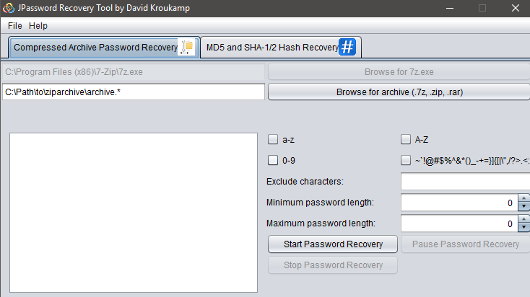The instructions document outlines on how to install the software and run it with supporting screenshots. I decided screenshots were a crucial part of the document as these allow the end user to visualise and confirm what it is that is required.

*Figure 5.1 Screenshot of JPassword*

Upon detailing the instructions and use of the software we decided to include a “sample file” of which the end user is able to “trial” the software. This is to ensure they do not lose any personal data on their files which they are using in the software for the first time.

Example software 2: WirelessKeyView

For this service we provided the software WirelessKeyView. WirelessKeyView allows the user to view the network keys stored on their device. This is beneficial to the end user as it allows them to obtain any Wi-Fi passwords they may have lost.

I detailed the instructions on how to run and install the software in the instructions document. I then also provided a screenshot of what the result should look like:

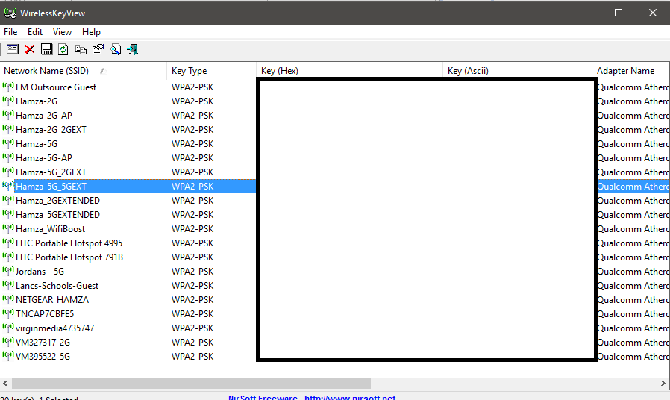

*Figure 5.2 Screenshot of WirelessKeyView*

The above shows the result of WirelessKeyView. The keys are displayed in the “key” field.

Example software 3: Lazesoft Windows KeyFinder

Lazesoft Windows KeyFinder is a tool which allows the end user to obtain their product key in the event it is misplaced or unobtainable. In most scenarios the product key is printed physically on the back of a device. However in some scenarios this can be an issue.

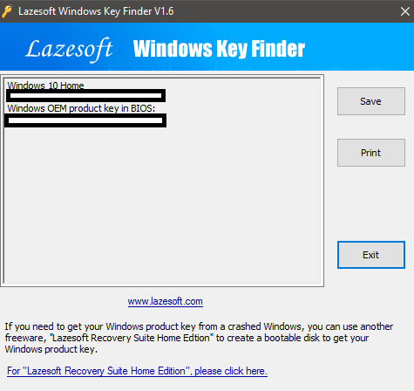The instructions document details and outlines the installation and execution of the software. Once installed it displays the result straight away. Below is a screenshot of what is displayed to the end user:

*Figure 5.3 Screenshot of Lazesoft*

As you can see above, the program has displayed the product keys for both the Windows installation and Windows product key

Example Software 4: Hardware Monitor

Hardware monitor is a software which reads the PC’s main system health sensors and provides detailed information all devices connected to the computer.

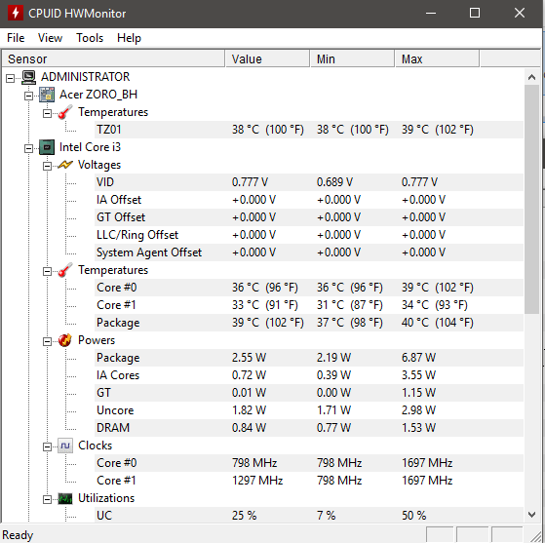Again I included all the installation and running instructions to the end user.

*Figure 5.4 Screenshot of Cupid HWMonitor*

Upon opening the software it provides a detailed breakdown on an all elements of the PC. For example:

Example software 5: Process Hacker

Process hacker is a great tool which allows you to monitor, debug and suspend all running processes on your system. The application displays data in a graphical GUI with different outputs in order to allow the user to monitor and manage their processes.

Again I included all the installation and running instructions to the end user.

I then provided the end user with a sample screenshot of what the application will look like. I did this in order to ensure the end user does not get confused and everything matches on their screen.

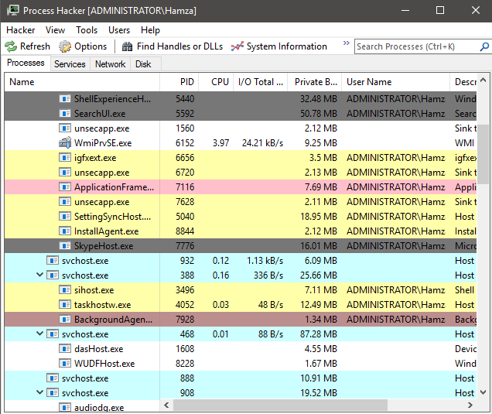Below is a screenshot of process hacker:

*Figure 5.5 Screenshot of Process Hacker*

As you can see, the software has listed all running processes using “colours” to show most memory consuming processes. The tabs at the top allow the user to run different commands such as find handles or DLL’s, terminate processes and much more.

## **5.4 Aims**

As a lot of computer forensic software is very complex to use and expensive, we decided to create an alternative which is creating manually defined packages with specific software that could be sold to potential customers.

As there are many organisations out there which charge extortionate prices for data recovery and various forensic processes, our aim is to create these packages with detailed instructions, providing a cheap and efficient service for the customer also allowing them to obtain an insight on how the forensic process goes.

Main aims:

* To provide efficient software.
* To provide supporting documentation.
* Providing a service to the end user of which completes all their requirements to the highest of standards.
* Providing support to the end user where required.
* Generating profit and sales by marketing of the software (as outlined in other subprojects)

These are the main aims which we have set out to be achieved. To provide a service that completely fulfils the customers’ requirements. These software’s are to be sold to individual customers, or also businesses with business licences.

## **In the next chapter:**

In the next chapter, my college Krystian Trzcionkowski will discuss the design and creation of the video instruction for the tools.

# **6 Sub-Project – Video Instruction Development**

# **[Krystian Trzcionkowski]**

In this chapter I will discuss the following topics:

* Introduction
* Overview
* Development
* Aims

## **6.1 Introduction**

In the following I am going to explain subproject I was required to complete. I am responsible for creating instructional videos on how to use the software distributed by our company. I will go over the objectives of the videos, give an in-depth look at how I approached designing every single video, discuss the recording and editing process as well as try to identify the issues that need to be solved to improve future development.

## **6.2 Overview**

Our company distributes a wide range of different anti-forensics software. There are some of them that are quite easy to use with very instinctive UI and not too many features which could possibly confuse someone. On the other hand, we also have a several programs who can be a little more complicated and could be slightly overwhelming to some of our less experienced customers. To make it easier for them, our company have decided to produce a series of video tutorials on how to use the software we provide.

The point of the video instructions I made is not to explain every little detail of what certain software can offer. Some of the programs in our packages can be fairly complex. Videos that go over every single feature of the program would be incredibly long and probably not very interesting to majority of our customers. Besides, our company doesn’t develop any of the software we distribute – few those programs were available for some time now and there are many online resources available for free that document all the details of the programs we provide (some even written by the developers themselves). Our instructional videos were created to help our customers take the first step, help them familiarise themselves with the user interface and show them how they can use main features of the software.

## **6.3 Development**

### **6.3.1 Designing and recording**

Before I could start recording videos, I had to pre-plan exactly what I am going to demonstrate in every single video. That required me to learn a little bit about the programs myself, because I never used most of that software before I started making those videos. Few programs in our packages can be used to do more than one thing, but I have decided that I will only demonstrate one feature in a single video. I tried to determine what an average user would need to use a certain program for the most and make a video exactly about that. I have also decided to not make videos about the software that is very simple to use and don’t really require any further explaining; an example of the software like that would be HWMonitor which only displays the detailed information about different components of the PC or WinAudit which, as the name indicates, displays an audit of your machine, both hardware and software. There are also few other programs in our packages that fit into this category. I figured that making videos about them is a waste of resources, because I don’t believe that any of our customers would have any problems understanding how to use them.

I wanted to make every video look nice and professional. For that reason, I made a few simple guidelines for myself to follow when recording the videos. First of all, every video starts from desktop window. At the desktop, there should be no other icons or folders for any software not directly related to the video I am making. Desktop wallpaper should also stay the same throughout every video, I figured the default Windows wallpaper would be suitable. I did not want the videos to appear casual and amateurish, after all those videos do in a way represent our company, that is why I had to do everything possible to make them look presentable.

I wanted the videos to be as short as possible. A lot of the times people who make video tutorials get distracted and start discussing things that are not very relevant to what they are trying to demonstrate. I wanted to avoid that and focus only on clearly showing every step, from start to finish, on how to use the program to achieve a desired effect. It resulted in every video being under 2 minutes, which I am very satisfied with.

Here’s a short overview of how I approached making every video:

**JPasswordRecoveryTool**

This video was fairly simple to make. This software can be used to do only one thing, so I didn’t have to think about what exactly I want to demonstrate. I prepared a password protected .rar archive, with a very simple password so that program will not take too long to crack it, reducing a time I need to make a video and making it easier for me later in editing phase.

**PCMark 8**

Even though PCMark 8 is a simply a benchmarking software, it actually took me the longest to record it. As I mentioned before, I wanted to showcase every single step, start to finish. To do that I had to actually benchmark my own PC. That doesn’t seem like a big issue, but running a recording software, which is very CPU intensive, and the benchmarking software that is supposed to put your PC components to a test to rate how well it’s a performing, made recording software crash a couple of times. Obviously I could have just pause recording for the time of the benchmark and resume afterwards to show the results, but I did actually want to show how PCMark is benchmarking the computer.

**HashSuite**

HashSuite is a software that have many features which can test the security of the password hashes, but I have figured the majority of our customers would be interested in its main feature which is cracking hashes. To make a video about it, I have prepared a fairly short list of LM hashes that I would use in my demonstration. I particularly have chosen the LM hashes because they are one of the easiest to crack, which means it wouldn’t take long to crack them and it wouldn’t tax my CPU as much during the recording, making it less probable to crash.

**Recuva**

File recovery with Recuva can be a little bit tricky, which is why I decided to make video about it. Obviously, to demonstrate how to recover files, firstly I had to prepare files that I would recover. Again, to not make it too hard for my CPU during the recording, I have decided to delete files from a brand new external hard drive. This way, when I scan the hard drive it will only show those few removed files, instead of digging through a ton of other files that I have removed during the years I have used my PC.

**NMAP**

NMAP is really complex software with a lot of different options and it’s definitely not a software for our less experienced customers. It is a network monitor, so I decided to demonstrate how I scan, in this example, Google’s public DNS and where to access the particular results from the scan. This video is slightly different from others because it involves a little bit more user interface presentation, simply because this software is quite a hard to operate compared to others I worked with during this subproject.

**Little Disk Cleaner**

I consider this program a very simple to use, but I thought I would make an instructional video for it because I expect that some of the less computer savvy users could be a bit hesitant to delete files from their computers in fear of removing wrong files which potentially could be damaging to their machines. The video should make it easier for them to remove the “junk” files from their computers without any problems.

**BleachBit**

Same as Little Disk Cleaner, this program is meant to delete files from your computer, though in this example instead of removing “junk” files, it removes cache, cookies and internet history to protect user’s privacy. It is very straight-forward to use, but because it involves deleting files I wanted to demonstrate how the process looks like, to avoid any confusion to our less experienced users.

### **6.3.2 Editing**

Before I actually started working on the editing the recorded clips, I had to decide which video editing software I would use. Initially, I thought that Windows Movie Maker would be a good enough choice. After using it for a little bit and running into multiple problems, such as downgrading quality of recorded clips for no apparent reason or working with only very few limited file formats, I have reached a conclusion that it does not satisfy my needs and started looking for suitable alternative. My choice was Camtasia Studio.

Camtasia Studio provided me with a lot of great tools that I could use to make the videos look really nice and professional. I needed a way to actually edit in instructions into the video since I didn’t record the voice-over for them. At first I was worried that doing this would make videos look bad and amateurish, but Camtasia Studio’s callout tool allowed me to that while making the videos appear really good and what’s the most important – professional. Also, callout tool allowed me to easily add arrows and spotlight effect, which are incredibly useful in properly guiding the viewer through the video instructions.

Just as with the recording process, I have decided to set few rules for my videos which would ensure that they will stay visually consistent and look clean and professional. First of all, all the object I edited in such as textboxes and arrows use the exact same colour throughout every video (dark red arrows and textboxes with white text inside them). I would also always follow the same pattern with their placement. Main instructions would always appear in a textbox in the bottom of the screen. When working with a program in a windowed mode, I would always slightly zoom in on the window to make video easier to watch and not waste too much screen space with empty desktop background. And whenever program is processing something for extended period of time, I would speed up the clip to not waste our viewers’ time on watching pointless loading screens.

Since there are no voice-overs for the instructions, I decided to add a background music just to make the videos more enjoyable to watch. After doing a little research I found a copyright free song that was suitable for the type of instructional videos I was making.

## **6.4 Aims**

The objective of instructional videos is to help our less experienced customers feel more confident about using the programs we provide, by demonstrating how to use them, step by step, to attain a desired result. Overall, the videos in its current state definitely achieve that goal, but there is still a big room for improvement.

### **6.4.1 What could be improved?**

First thing that needs to change is the number of videos produced. I believe that concept of short videos focusing on a single feature is the right approach, but I also think that there should be a lot more of those short videos. It’s actually an easy improvement that can be gradually made as the company operates. Ideally at one point there would be a large database of videos that cover all the major features of every software we provide.

Another thing that would improve the videos in my opinion is adding a well animated intro and outro to the videos. Right now videos start with a single panel with the title of the video, which does serves its purpose, but I believe that a unique intro, with our logo and maybe a short music instrumental created specifically for this animation would make our instructional videos look nice, distinctive and memorable to our viewers. This intro wouldn’t have to be used only for video tutorials we provide, we could also use it for any other sorts of videos we want to publish, like announcements or TV commercials.

Currently the videos don’t have a voice narration and do require a viewer to read the instructions displayed in the video. I don’t consider this a high priority, but I believe that voice-over, as an addition to written instructions would be ideal. It would make video more comfortable to watch for some of the people, but I don’t think the voice-over should replace the written instructions entirely though, as we could have customers with hearing impairment that would not be able to watch the videos we provide.

## **In the next chapter:**

In the next chapter, AFS’ website developer Adam Morrison will discuss the design and development process of our company website, as well as provide a justification of resources used to host it.

# **7 Sub-Project – Website Development**

# **[Adam Morrison]**

In this chapter I will discuss the following topics:

* Introduction
* Sub Project Aims & Objectives
* Web Development Research
* Web Development Outcome
* Problems & Solutions
* Future Development and Plans
* Justification of resources used to host & develop the website

## **7.1 Introduction**

AntiForensic Solutions is an electronic commerce retailer specializing in the sale of anti-forensic tool kits. As such it is vital that the company has a professional website, suited to fit the needs of modern day users. My role within the team was to design a dynamic website ready to be deployed on the web. As well as a distinctive company logo that clearly expresses our brand name.

## **7.2 Sub Project Aims & Objectives**

### **7.2.1 Key Aims & Objectives**

As I was the soul website designer I sought to stick to these aims & objectives bellow to unsure the outcome of the website design was successful. I also had to design a logo for the company which suited the latter two aims listed below.

* **Professionalism** – Showcasing the company in a good light through the website
* **Functionality** – Accessibility and reliability with the e commerce system
* **Recognized Brand** – Creating a suitable logo related to what the company offers
* **Global Recognition** – Marketing through the website to attract new customers
* Allow users to purchase products through the website with an easy step-by-step system
* Promote the brand and products through means of the website
* Insert tutorial pages for each of the products available, including detailed instructions (instructions *created by Hamza*) and clear example videos (videos *created by Krystian*)

### **7.2.2 Websites functional needs**

The website had to be carefully designed from the outset to meet the criteria listed above. As an e-commerce company the website was not only the company’s global brand but also the means of selling our range of products. Customers need to trust us as a retailer in order to purchase our products, this initial trust can be gained through clear brand recognition or through a professional website design.

## **7.3 Web Development Research**

### **7.3.1 Design**

The standard for website design is changing rapidly. I looked carefully at where the trend was moving and set out my research on some of the top e commerce websites. I discovered that all of the highly rated websites have a clean easy to use layout, mainly using a white background for content areas and an “impact page” where the company brand is clearly displayed in front of a strong background image. I looked into freely available information on the impact of web design on users. From this research I found “65% of users will not trust a website if it has an unprofessional appearance” [Visual.ly, 2016]. There was also statistics available on website structure and appearance, such as Blue being the most popular colour (24%) chosen by users. I looked into different colour pallets and found a website that offers free colour pallets [Color-hex.com]. I eventually decided to use the following colour palette. (See Figure below)



*Figure 7.1 Colour Palette used on Website*

### **7.3.2 Development Process**

### 

*Figure 7.2 Image of Development Process*

* Information Gathering

The first stage of the development process was to gather and process as much key information as possible. I set out by asking the other team members exactly what was required of the website. We decided the purpose of the website would be to sell our products to customers and market our brand globally. The goal was to have a functional e commerce website with a professional and clean appearance. I also had to find out who the target market would be in order to make the content of the website relevant.

* Planning

The planning stage of the process tied in, almost exclusively, with the information gathering process. Once I had collected all the information possible it was time to analyse it and create a clear structure and plan for the development of the website and logo. I also had to decide what web development architecture I would use for creating the website. This linked to the first stage with research into all the different technologies available.

* Design

I had a clear idea of how to make the design fit into what the company was about. From my research I created a comprehensive list of the requirements of the website design. I then used this information to create some initial drafts for the website design.

*Figure 7.3 Initial Website Draft*

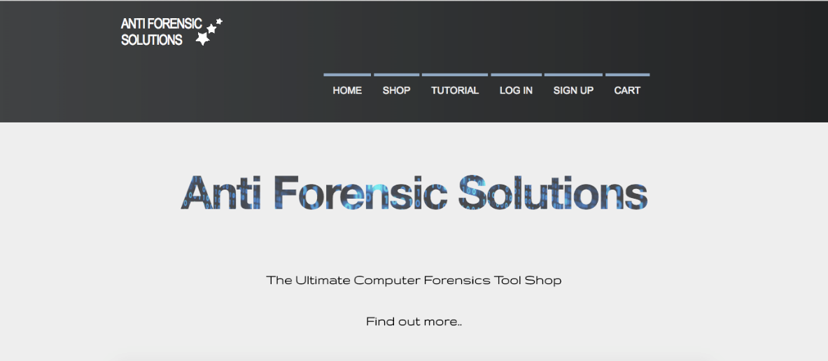

This was the first design I came up with which gave me a general structure to build upon throughout the development.

* Development

I was now at the stage where I could actually start creating a functional website. I used the designs of the logo and some mock up website designs as a basis. I first created the front end of the website using HTML 5 and CSS3 in sublime text editor. Once I had a near complete website I was then able to start working on the server side part of the website using Java Apache Tomcat (JSP & Servlets).

* Testing

Once the website was completed I began testing the functionality of forms and scripts. I also tested the websites optimisation for different browsers / screen sizes. I tested the website on the following:

* 22 Inch – Chrome / IE / Mozilla
* 11 Inch – Chrome / Safari
* 29 Inch – Chrome / Safari / Mozilla
* Maintenance

Once the website is up and running maintenance is key to keeping it functioning smoothly. I will check on a regular basis for updates to keep the website secure. With web technologies constantly changing I will have to keep myself up-to-date with current news in the industry to ensure the website runs to the highest quality.

### **7.3.3 Technical Requirements**

As it was going to be a dynamic website with a working e commerce system it had to be developed using a number of different architectures. The front-end programming was developed using Sublime Text 3, which is a free text editor program. I then imported this into an Eclipse ‘Dynamic Web Project’ so I could start work on the functional parts of the website using an Apache Tomcat server and programming in Java. I also had to create a database to store information, such as user credentials and product information.

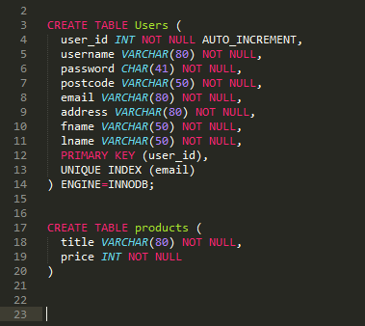

*Figure 7.4 Example Database Code*

*Figure 7.5 Example Database Output*

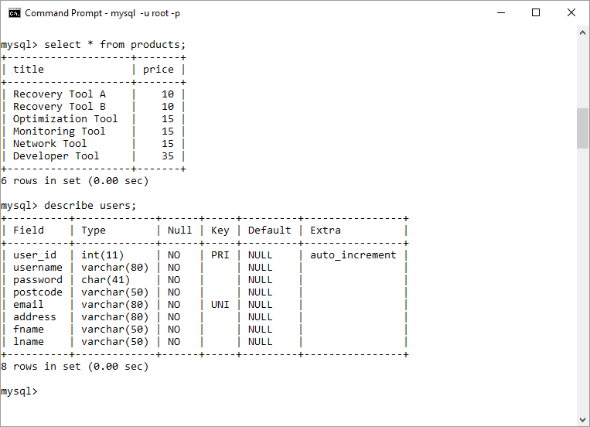

### **7.3.4 Legalities**

There are certain requirements a website has to adhere to, more specifically e commerce websites.

There is a new legislation on cookie law. Websites must tell the users if they are using cookies and clearly explain what each cookie does. There is an exemption for cookies that are required for a shopping cart; therefore I did not need to include information on the cookies I used. [ico.org.uk]

I must also include a privacy policy page and contact information for our company, this information I have included in pages accessible from the footer as shown below.



*Figure 7.6 Website Footer including Privacy Policy*

There are a number of laws for e commerce websites. I researched into this and found some key legislations we must comply with on the website. [legislation.gov.uk]

* Acknowledge receipt of the order to the recipient
* Provide correct information to customers

### **7.3.5 Online Deployment**

The website will be deployed on a Tomcat server using cloud hosting. I have looked in to all the different web host providers and decided Amazon Web Services would be the best option, at least for the first year. It offers a secure cloud based system capable of running Java Tomcat.

## **7.4 Web Development Outcome**

### **7.4.1 Website Design Outcomes**

* Clear structure and consistent layout on all pages
* Easy navigation throughout all pages
* Clean design, not too animation heavy to decrease loading time

### **7.4.2 Logo Design Outcomes**

* Expresses what the company is about
* Clear brand consistent with the website design
* Company name used as the main structure of the logo

### Macintosh HD:Users:adam:Downloads:logooo.png**7.4.3 Finished Product**

*Figure 7.7 Anti Forensic Solutions Company Logo*

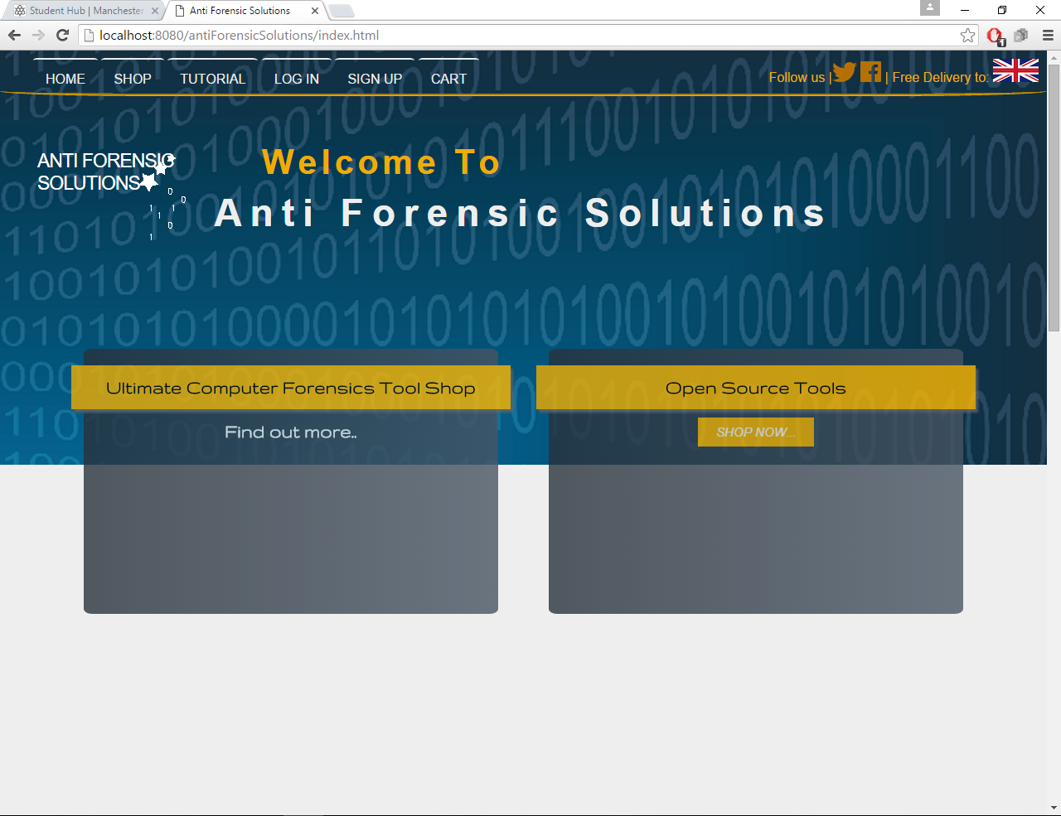

*Figure 7.8 Anti Forensic Solutions Website Homepage*

This is the home page presented to the user when they visit the website. It has clear navigation to all pages as well as the social media links. The first of the two promotion boxes takes the user to the tutorial page where there are embedded YouTube videos showing the products in use, and the later of the two takes the user to the online shop.

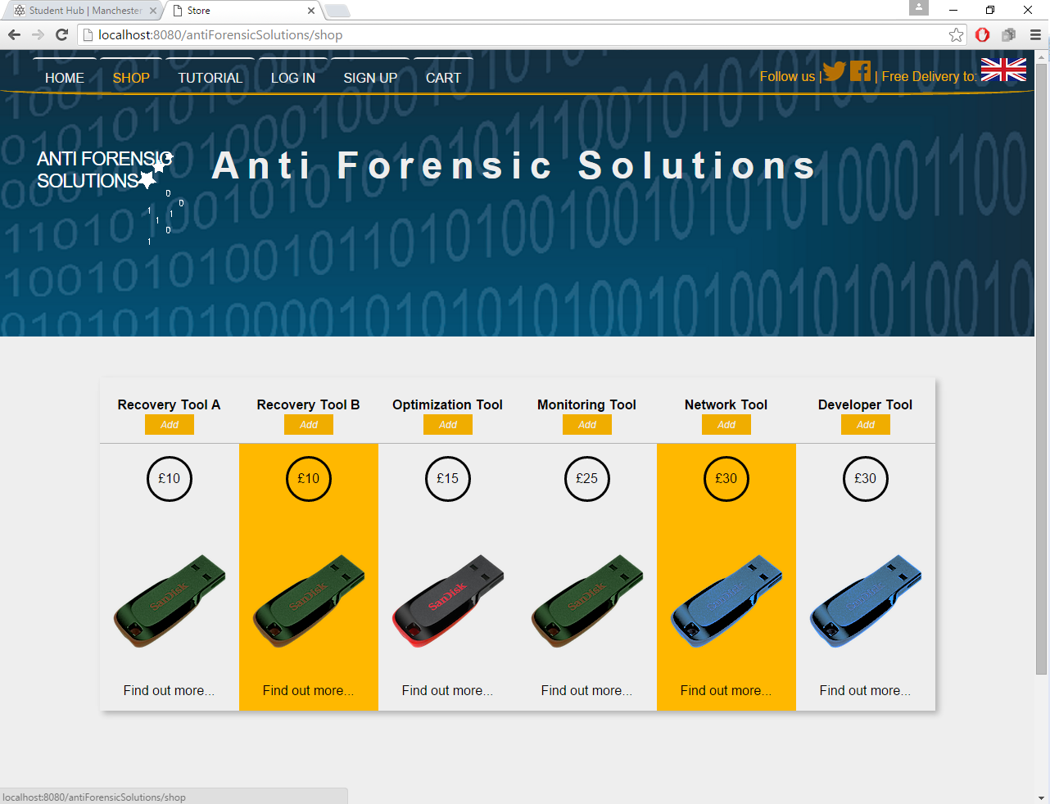

*Figure 7.9 Anti Forensic Solutions Website Shop Page 1*

This is the shop page on the website. It displays the name of the product and the price (returned from the database), as well as a link to a page where the product is described in detail with comprehensive instructions (*instructions created by Hamza*). There is also a button to allow the user to add the item to the shopping cart.

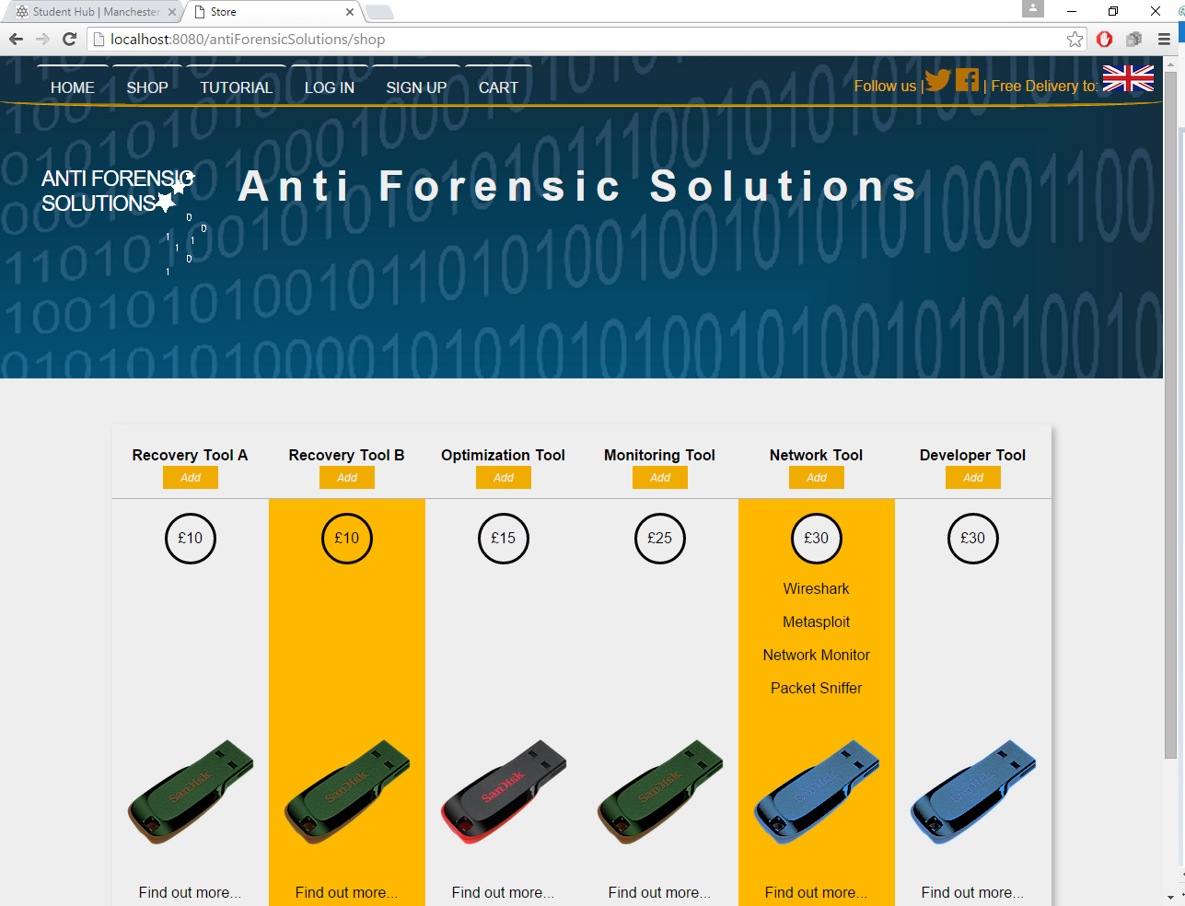

*Figure 7.9 Anti Forensic Solutions Website Shop Page 2*

If the user hovers over the price of the product it creates a drop down list underneath giving details as to what is on the product.

*Figure 7.10 Anti Forensic Solutions Website Shopping Cart 1*

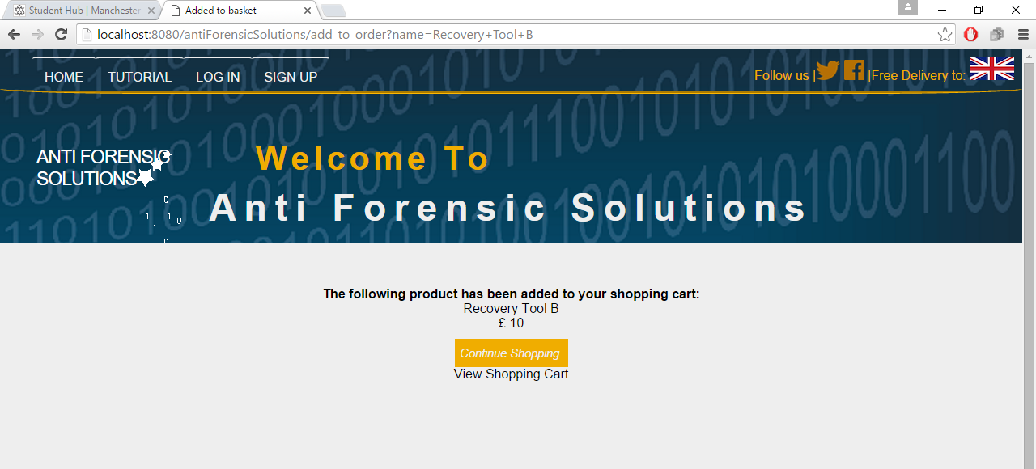

Once a product from the shop page has been added to the cart it takes the user to this page where it displays the product information. The user can choose to continue shopping or view the shopping cart.

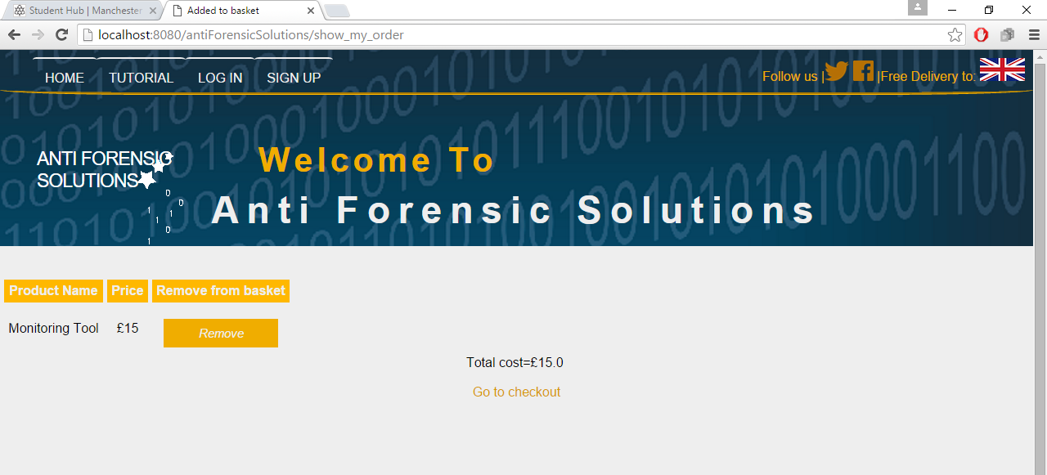

*Figure 7.11 Anti Forensic Solutions Website Shopping Cart 2*

Here is the shopping cart with the product inside and the total price. There is also a link to remove the product from the shopping cart.

*Figure 7.12 Anti Forensic Solutions Website Login Page*

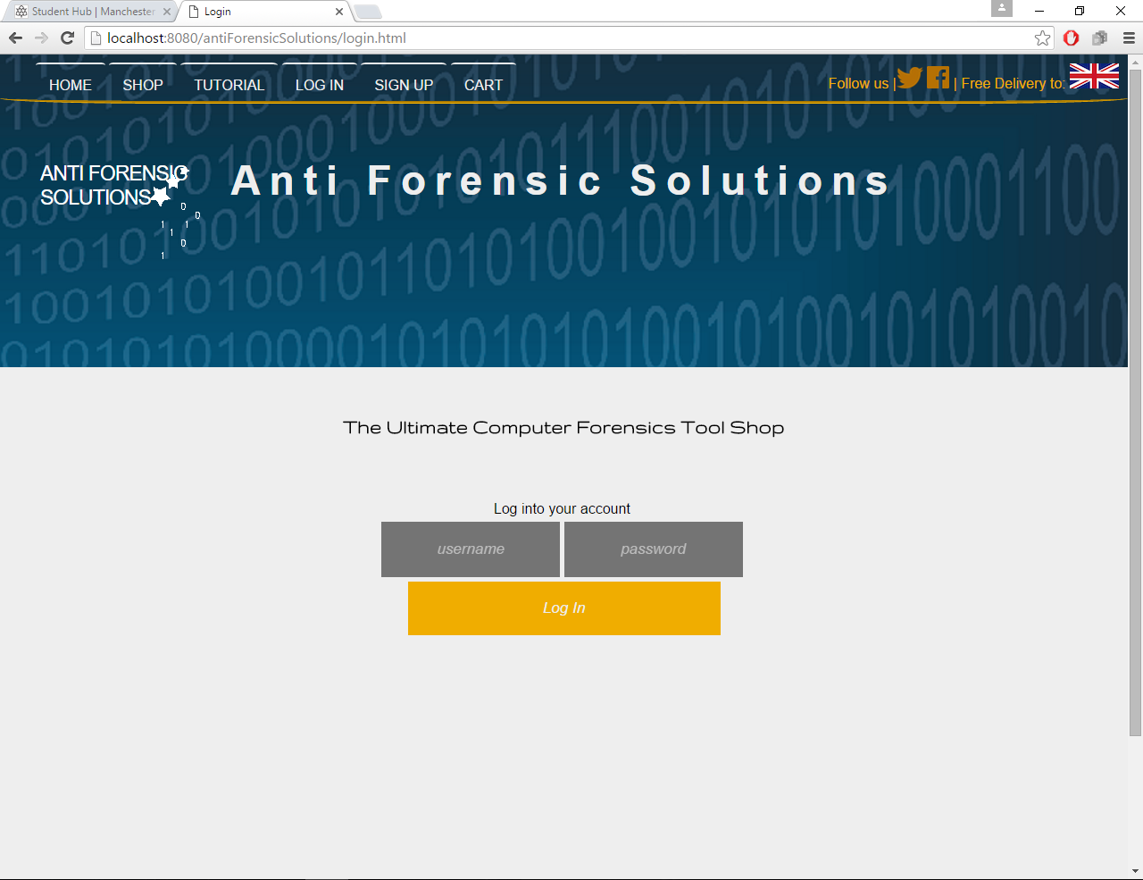

The user also has the option to log into their personalised account page to view their order history

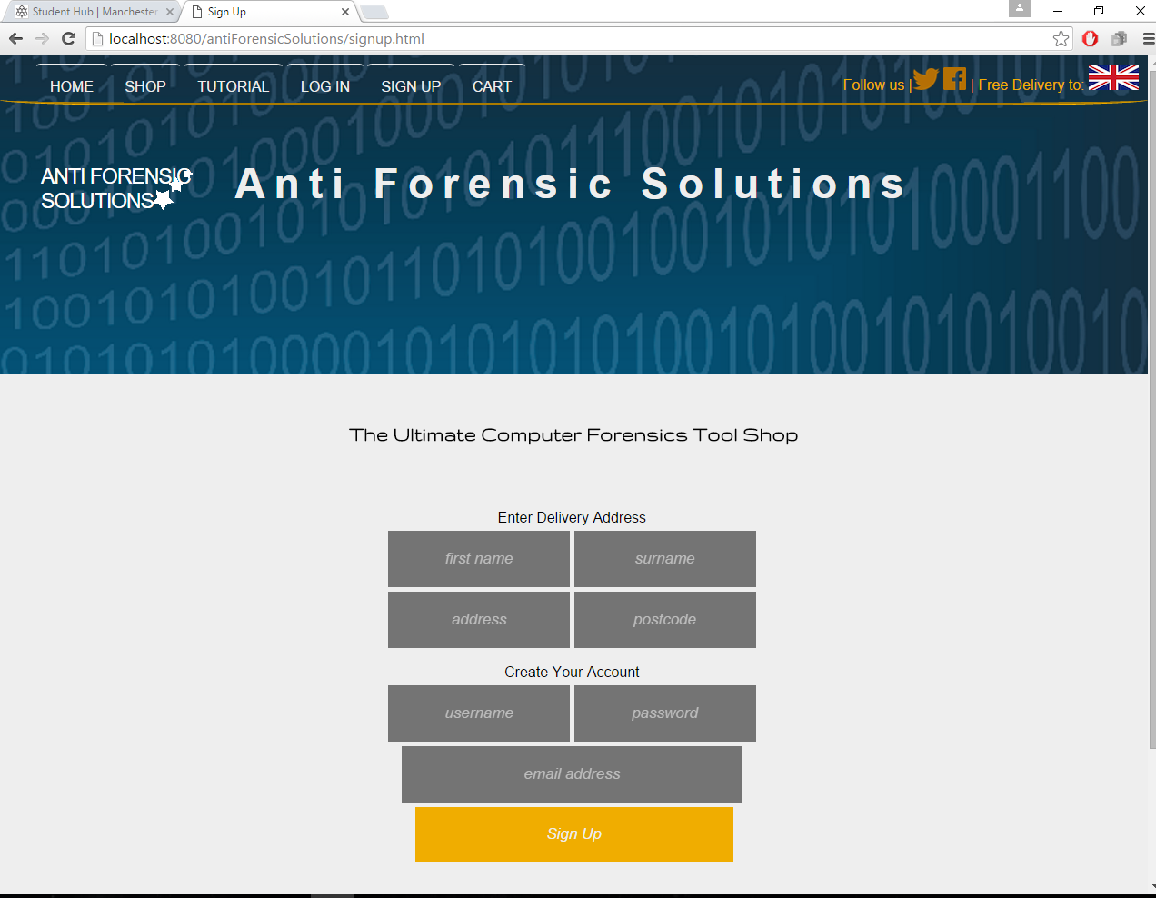

*Figure 7.13 Anti Forensic Solutions Website Sign Up Page*

On the sign up page the user can enter their delivery details, which will be saved in the database.

## **7.5 Problems & Solutions**

### **7.5.1 Problems & Solutions**

One problem I came across was trying to get the web application to appear correctly on different screen sizes, with no incompatibility issues on varying browsers. I had to include a number of fall-back methods within the CSS to ensure the browser displayed the web page similar to as I intended.

## **7.6 Future development and plans**

### **7.6.1 Google Analytics**

I plan on adding Google Analytics to the website to help us measure our growth and learn about how the users navigate our site so we can optimize it even further to suit their needs.

### **7.6.2 Google and Facebook Login**

The majority of web users have either a Google account or a Facebook account. Some people might be put off by using the website if they have to create an account. Allowing them to use their Google or Facebook account to log in will not only speed up the process for them, but also offer a secure way for them to use the website.

### **7.6.3 SSL Certificate**

Before the website can be deployed to the web I will need to purchase and set up an SSL certificate to keep our customers data safe and secure. After researching all the providers of SSL certificates I have decided the best option available is GlobalSign Inc.

### **7.6.4 PayPal**

As customers will be purchasing products from us using the website I will add an option for them to use PayPal as a payment method. This allows them to securely pay for goods with their credit/debit cards. It is a simple feature to add to the website and we just need to set up a business account to get started.

### **7.6.5 Domain Name Registration**

I have compiled a list of potential domain names and checked them against DomainCheck to see if any of them are available. The domain “AntiForensicSolutions.com” is available for purchase and is the most suitable domain for our company. We also have the option of purchasing other top level domains to go with that, such as “.co.uk”.

## **7.7 Justification of resources used to host & develop the website**

### **7.6.1 Host Provider**

Here is a graphical list of the host providers I looked into.

*Figure 7.14 Online Host Providers used for Research*

Out of these host providers it was clear that Amazons Web Service was the best option for our company. Not only is it one of the most popular web hosts available, used by companies such as Netflix and Slack, it is also free for 12 months. After the 12 months have expired the price plan is very reasonable as it scales depending on your usage, thus reducing unnecessary costs.

### **7.6.1 Technologies**

All the software I used to develop the website was completely free. I felt it was unnecessary to pay for software for developing the website. Apache tomcat was the obvious choice for the server side software as it the most widely used and free.

## **7.8 Sources of Information**

<http://www.color-hex.com/color-palette/1837>

<http://visual.ly/why-good-web-design-so-important-your-business>

<https://ico.org.uk/for-organisations/guide-to-pecr/cookies-and-similar-technologies/>

<http://www.legislation.gov.uk/uksi/2002/2013/contents/made>

<https://www.globalsign.com/en/ssl/domain-ssl/>

<http://www.google.com/analytics/#?modal_active=none>

<https://developer.paypal.com>

<http://www.mochahost.com/java_servers.php>

<http://www.2020media.com/tomcat/java-tomcat>

## **In the next chapter:**

In the next chapter, my colleague Collins Nyange will discuss the design and development process of our company’s advertising and social media presence.

# **8 Sub-Project – Advertising and Social Media**

# **[Collins Nyange]**

In this chapter I will discuss the following topics:

* Introduction
* Sub Project Aims & Objectives
* Advertising Research
* Social Media Research
* Problems & Solutions

## **8.1 Introduction**

AFS are a creative and efficient company, specialising in producing secure bootable pen drives to improve PC performance as well as recovering important data on our PC's, laptops as well as mobile phones. Our service aims to decrease the pressure, time and money as bringing solutions right to our clients. As a method of getting to reach out to our clients, we’ve used Social Network platforms such as Instagram, Facebook and Web banners.

## **8.2 Sub Project Aims & Objectives**

Social Networks is an increasing exposure for Companies, increasing each year. As from our research we conducted in our University there's a great majority of students connected to various social network platforms. Facebook being the highest followed by Instagram as well as Snapchat. As a team we discussed that Facebook and Instagram being a great start to advertise our Company and expose ourselves to the public/Market. Our company will emphasise on services and support to differentiate ourselves from software and/or product sales oriented companies.

Our aim is to;

* Produce exposure to our clients,
* Produce Market insight,
* Establishing and improving our sales.

## **8.3 Advertising Research**

Advertising research is a specialised form of marketing research conducted to improve efficiency of advertising. Our company have used customized research, conducted for a specific client to address that client's needs.

Our advertising research will focus on ads and direct an understanding about our profile through our own website we designed as well as posting ads onto social media platforms i.e. Facebook, and Instagram as well as engaging with clients moreover bridging the expanding gap in the market need for password/wireless recovery, data protection, improving pc/laptop's performance and monitoring network activity.

Pre-market research can be conducted to optimize ads for any medium optimize advertisement for any medium: radio, television, (print newspaper or magazine), billboard, or internet. Our Company have created billboards and posters to advertise our profile. Moreover due to costs magazines, newspapers and television require a large amount of money as the platform would increase our awareness to the community. This is one improvement we could add, if we could administer more capital this would be very ideal for AFS to create even a higher market insight.

Our target is PC and laptop users, our products are user friendly and do not require high IT skills. From Ages 13 to as far as 60+. We will target these population with posters, Facebook ads and maintain communications with the online communities i.e. Facebook, and make use of our specialist abilities to offer intermittent help and advice in forums on our website to raise our profile, build a reputation and gain trust.

Anti-Forensics Solutions will trial the effectiveness of web banner advertising and monitoring the success rate depending on the interest conclusion as a result. Depending on size of banner, average cost of advertising monthly is £6 – £25 per thousand impressions but it would need to be trendy and eye catching therefore periodically changing the design, in order to try and counter the decline.

We will also trial the effectiveness of posters to advertise our profile, this would include time and commitment with the team speaking with nearby businesses e.g. Il Padrino and Abduls takeaway opposite of the All Saints Park and ask if we could put up our posters in their store. Fortunately this does not require any costs as it is free to use these stores to put up our posters. We will advertise our launching event through our posters as well as a summary of our products. They will be eye catching and designed to provide enough information needed. We would need to produce these posters for what we want to achieve thus meeting our objectives

Figure 8.1 shows the Facebook profile page I have created. I have stated out mission and a brief summary of who we are.

*Figure 8.1 Anti Forensic Solutions Facebook Page*

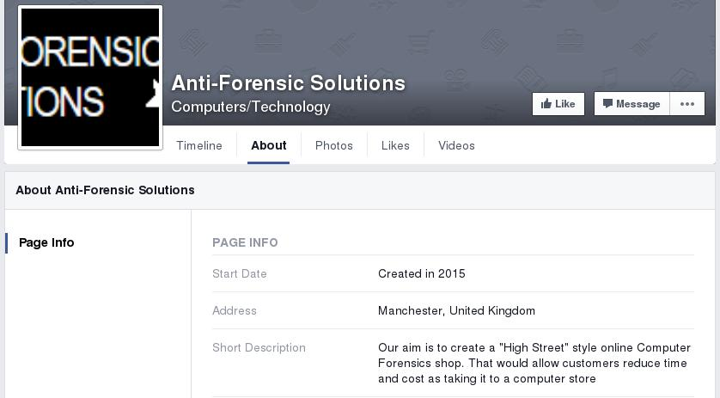As you can see from we have created a Facebook page however is going to be improved with time, as firstly we need to look into our website, local advertising as well as newspapers and magazines. Newspaper and magazines would be included for later use as it is another great form of producing exposure. Although resources would be very important on this stage as we would include more people in our Department so as to write articles for different magazines, producing our own blogs and communicating with people in need of help.

## **8.4 Social Media Research**

Social media is a form of peer-to-peer communication that has become a popular way to connect with new and existing customers. Online social media and networks have a growing role in marketing, which has important implications for how consumers, channels, and companies perform. In social media settings, consumers provide online feedback about products, and this feedback is visible to other agents, including other consumers, channel partners, competitors, and investors. - <https://www.ama.org/publications/E-publications/Pages/ama-journal-reader-july-14-social-media.aspx#sthash.hL9atNkv.dpuf>

Due to the nature of our product/business, we require a high SEO and social media advertising is needed. Our company decided on creating a social media account such as Instagram, it’s fairly easy to set-up and use. Firstly, an email account is needed to create an account, I created a Gmail account as it is secure as compared to Hotmail but still has its cons as Gmail collects data from the users and could lead to complications. Compared to Hotmail, Gmail offers more security as hackers have always get their way with their database.

Firstly we used Instagram, it is a great platform to connect with customers, as it has grown immensely ever since it started, although it does require time to advertise the account. We have linked it with our website and Facebook as well. This would allow us to increase our market exposure. With the rising population and increasing use of the Internet with new technology, in a few years to come most of the population will be connected with social media accounts.

As studies shows around 40% of the world population has an internet connection today. In 1995, it was less than 1%. The number of internet users has increased tenfold from 1999 to 2013.

Therefore we have created a website of our own currently being developed by our Web Development department, led by Adam Morrison and Collins Nyange. It will declare our company mission statement and will present our company and our services in a very clear, very professional, easily accessible format. Moreover customers could register on our website and will be able to order online as soon as our products go on sale. Our website is aesthetically pleasing and simple to navigate around. It can currently be reached via www.anti-forensicsolutions.biz and will soon be launched onto the University Domains.

Secondly Facebook is another platform we created to reach out to greater community of people thus creating a greater market insight. Our page would consist of our Company profile and updates of our products and also provide a community forum whereby everyone can leave a comment. And with our Social Network department would be able to consult with people one to one and assisting them with whatever they require 24/7. This would benefit us as studies show that the daily active users Facebook is **1.01 billion** on average for September 2015, an increase of 17% year-over-year. This shows the amount of people we could reach out to worldwide.

Although using a social media is an advantage for our company but it has it disadvantages, firstly it is time consuming. Utilizing a Facebook page to produce exposure with the customers is very time-consuming if done right. In addition watching out for negative comments, as a business such as ourselves we will try respond in a respectful and professional manner. Secondly advertisements is cost effective in order for Facebook to promote our page. Paying £4 as a starter to reach out locally for a specific amount of time and increases with the area radius in which you want to advertise for your company. However social network ad campaigns would increase the traffic to our website and improve rankings on search engines as well.

## **8.5 Problems & Solutions**

In conclusion social media and advertising is a great strategy any business can use to create exposure to the clients/market. Through our website we established how customers would be able to buy our products as well as communication; moreover creating a link of both our Facebook and Instagram accounts. It is important that we continue to market our company effectively, to maintain the balance between profit and loss, and compare with our competitors as well as keeping our strategies focussed on our growth. Our advertising will evolve and change as necessary to stay updated meeting our short term as well as long term goals.

One solution we will implement in the future is exploring the benefits of TV and Radio advertising, and capitalize on further online advertising services such as YouTube and Google ads. We could implement the Cost per Click internet marketing strategy into our advertising campaign with Google Ads. We are currently aware of no threat posed by competitors when searching AFS therefore we would decide on a reasonable cost to ensure the links between our website will be first to displayed on the search results.

We encountered that TV and Radio advertising has a great costs. A rough perspective, a week long campaign that uses a 30 second ad without production costs could cost anything from £500 on a local station and can increase to £10,000 on a national station. As we continue to grow as a company, from increasing sales and profits we could afford to advertise into higher level of advertisement strategies.

Time and resources is one of the biggest drawbacks we encountered of having a Facebook page. Our Social Media team understood that it does take time after setting up the Facebook page for people to start following us. As well as maintaining the page takes time, resources and energy. Therefore our company would require a dedicated member of staff to monitor and respond to posts on a regular basis, and fortunately I, Collins Nyange have been appointed to do so. Moreover we did encounter that it is cost effective advertising on Facebook however a reasonable advertising budget would be essential to the success of our Facebook page. We have experienced very slow growth however in time and essential budget we are projecting a rise of activity in both our website and social media platforms.

There are other social networks we could have used such as Google+ but none come close to Facebook's overwhelming user base of 1 billion. In my view, if you’re willing to put the time and resources into your business's Facebook page the positives outweigh the negatives. Setting up the Facebook page and how we utilized its applications for our business depended on our Company on a case to case basis. Our first case basis was encourage a market insight as well as increasing exposure with our clients.

In conclusion with the increase numbers of Facebook and Internet users gradually increase each year it is a great potential for new businesses to utilize to gain a market insight and produce exposure. Thus sales would start to rise as we would be achieving clients. Thus our aims would be met through this marketing strategy. Although there are various negatives however the positives outweigh these. Social media and advertising is very important for a business to create exposure. Additional advertisements such as Google+, LinkedIn and Snapchat could be a great potential and increase our market insight. As a company we would discuss and implement new ways we could add these in achieving our long term goals.

## **In the next chapter:**

In the next chapter, my colleague Ryan Malaney will discuss the finance section of the business including projections for profits for the first three years of trading.

# **9 Finance**

# **[Ryan Malaney]**

In this chapter I will discuss the following topics:

* Initial Expenditure
* Marketing
* Wages
* Projections & Sales

Within the financial sector of this project we knew that we would have to be smart with our money because as it stood we had a small idea that if implemented correctly, we would be able to make huge strides with so it was very important for us to get the finances correct and arrange them around having the least amount of expenditure whilst still having quality resources, and also still being able to make money over a period of time.

## **9.1 Initial Expenditure**

After the wages were taken care of we then needed to start thinking about where we wanted our base of operations to be so that is where extensive research was put in, in order to find a work place located in the centre of Manchester and what was even more efficient was the cost of the place, per month including the use of a telephone line, gas and electric and running water, the grand total was £1600 a month which is a very good price especially when we considered where it was and how advantageous this position would be for us and the future of our product.

After figuring out where our base of operations was to be conducted we then needed to find vendors and reasonably priced sources of hardware to enable us to prepare and distribute our product to the general public. So we began by locating multi-faceted companies that could provide us with packaged to get out operations running smoothly and as efficiently as possible. Having considered the size of our team it would have been counterproductive to go with a company that only offered huge enterprise solutions for our needs so we had to look for something a little bit closer to home and that is what we did, we located a company that for the price of £833.33 a month would provide us with an extensive list of materials and hardware we required in order to perform tasks such as the web designing and maintenance, customer relations and so on and so forth (ask dale for a review on this particular section if needed)

The company provided us with the following to aid with the start up.

Computers

Printers

Chairs

The only thing we needed to outsource to a company who had a reputation that preceded them was for a server to store all our client information with secure connections at either end and also data related to the website, we had to do this simply because if we ourselves would have undergone doing this we’d have spent more money trying to get one server up and running and in that time we could have rented out 100 servers at 10 different server farms in the country, so for that reason alone we decided to outsource and this cost us the tiny sum of £9.95 a month which is a steal in the grand scheme of things.

After the tools where taken care of we then sorted out by locating a validated and reliable vendor for the pen drives and we did so via using the alababa.com services and was able to acquire 1000 pen drives for £117.50 and we based our goals­­­ around selling the pen drives by the thousand a month. This seemed like a good starting point for the company and the sale goal as it would allow us to have enough pen drives to keep up with demand providing there is one and also allow for the possibility of quick sales if the idea flopped and proved insufficient for what the people want.

After locating the vendor for the pen drives we needed packaging materials and we went with a hassle free approach and used a bubble wrapped package in which when the tools are loaded on the pen drive th­­­­­ey would be simply put in to the wallet and stamped with a shipping address and sent away, the bubble wrap ensures safe travels whilst in transit from us to the buyer. The envelopes cost us £13.33 and again that is for the sum of 1000 envelopes.

One final but crucial part of the resources needed in order to allow us to move forward with the product was as SSL certification from a reliable and credible vendor, this certification would allow us to give our customers peace of mind when it comes to any purchases that would be made online.

The SSL certification not only secures personal information about our clients but also ensures that no malicious entity can snoop on what it is the customer is buying nor will they be able to access information such as user logins or emails as easily as it would be without it, we have employed this to let the customers know we are serious about keeping their information safe and that we value their custom very much so.

The price for the SSL certification is £129 a year which when considering what it does it relatively cheap in comparison to a letter from a solicitor demanding compensation to a client for actions that have been taken upon them simply because of using our services, so we opted for the safe option and decided to employ this simple but effective counter measure.

## **9.2 Marketing**

The next and most important part of this whole campaign would have to be the marketing aspect and we needed to ensure we got this right, so in order to give the marketer the freedom to really sell our product we allocated marketing £4166.66 a month and this was for advertising on billboards in central Manchester and around the area as well as ads online and via various social media websites that would allow such activities.

We also allocated £20,000 for a launching event that would span two days in total, further details should be located within the marketing aspect of this document, the two-day event will be primarily for showcasing the product and what it can do, who it’s for and we will be offering the business owners who show up to the event a free version of the tool so they can take it home and have their own demo of it in their own homes to truly see how effective something like this can be.

## **9.3 Wages**

So to start out with we all needed to come to an agreement on what our labour costs were going to be and that was one of the most important aspects of this project as without us the product would not get to the market so in order to keep the balance and keep people happy we decided to pay each individual £30 p/hour but and they had the ability to choose when they wanted to work but we also set a condition that any individual would only be able to work a maximum of 3-4 days a week thus enabling the freedom for our colleagues to choose when they want to work and also dictate how much they want to earn a month.

Each individual earned £6,240 in the first year of the project development/marketing phase and in total for wages we used £62,400 which in turn used up just a little over a fifth of the overall budget for the first year.

The reason we had to set the bar so low in terms of wages to start out with was because in order for us to market our product effectively and also maintain a contingency plan if things did go south, this was one of the areas we collectively agreed on that we would make sacrifices on seeing the bigger picture later down the road when all the profits started rolling in and then our team members would get a completely different wage and may even include bonuses. This would be based off of the standalone wage of £520 a month then this would increase with a percentage of what the earnings where each month, making the overall bonus at the end of each year that much greater.

## **9.4 Projections & Sales**

So now we come down to business and discuss the price of our product, we first needed to acknowledge what it was exactly we were offering the people and that was a new answer to privacy and a firm grasp of ones independence as citizens, we decided upon 7 tiers of the product ranging from the very basic password recovery tools, then we moved up to erasers and file shredders and so on and so forth, the very top tier allows customers to customize their own pen drive with whatever tools they desire all in one package, We decided to do it this way in an attempt to accommodate for every requirement a customer may have.

In our first year of sales we have an aim of making around £20,000 thousand a month to start out with but this is just a minimum figure and we expect it to be a slow start but then soon after the first year we would like to be making in the region of around £45-£50,000 a month after taxes, this is well within reach for our company taking in to consideration the type of product we are offering the people, in order for us to make that kind of money in the second year we would need to buy more pen drives but providing the business flourishes then we should be absolutely fine as we do not have any debt nor did we require to go in to debt for the launch of this product.

So in total there are 7 packages which each have their own price tag, package 1-5 cost £15, package 6 which contains every tool all in one pen drive cost £60, and package number 7 costs £17.50 and this is designed for people who only want specific tools putting on the pen drive, the £17.50 charge is incur every time a tool is added to the bundle so for example a customer would choose to get the wireless password recovery tool and the eraser tool on one pen drive instead of purchasing two separate pen drives, this would then equate to the cost of £35 for the pen drives then add another £2-£3 for postage and packaging thus having a total of £38 net.

We expected a slow start in terms of sales in the beginning but after the first 100 sales we are aiming for a steady incline in sales, this is displayed on the graph below and as you can see we exceeded our own target.

*Figure 9.1 Anti Forensic Solutions Expected vs Actual Profits Year 1*

Please see the appendices for my three year projection cash flows.

## **In the next chapter:**

In the next chapter, my colleague Dale Stubbs will discuss the project review and analysis. He will also conclude this report.

# **10 Project Review and Analysis (Conclusion)**

# **[Dale Stubbs]**

Within this chapter I will discuss the following four topics:

* Project Strengths
  + Cohesiveness
  + Communication
  + Time Management
* Project Weaknesses
  + Attendance
  + Deficiency of knowledge
* Communication Analysis
  + Student Email
  + Moodle
  + Team meetings
  + Google Drive
* Have responsibilities been carried out?
  + Tasks completed
  + Deadline met
* Overall Conclusion

This will provide an insight into the operation of the project and emphasise any problem areas that became apparent whilst also enlightening all of the areas where we excelled.

## **10.1 Project Strengths**

### **10.1.1 Cohesiveness**

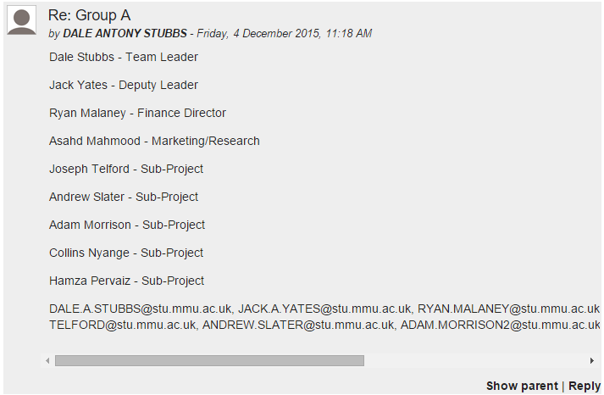Our greatest asset was our cohesiveness from the offset. Within the first twenty minutes of creating the team everyone had made a decision as to which title each of the members was going to take on. As I was the oldest, and therefore the most experienced, member of the team I was elected as Team Leader and within minutes everyone was assigned their chosen roles with absolutely no conflict to attempt to resolve. Initially we had nine team members and a tenth was added following the Christmas Break. Adding the tenth member to the team was a challenge however we succeeded nonetheless.

*Figure 10.1 a message from the online forum*

### **10.1.2 Communication**

Throughout the project we utilised multiple forms of communication which will be analysed later within this chapter. The effectiveness of the communication resources we required was key to the overall success of this project as communication is key within most aspects of life. We found that the most effective source of communication was the scheduled team meetings on a Friday morning during our Professional Development lab session. This source of communication was especially effective for analysing the requirements that each team member required in order to meet their ‘internal’ deadline and allow the subsequent team member to proceed unimpaired.

### **10.1.3 Time Management**

Time management was also one of the most demanding aspects of this project. All of the team members had multiple commitments to other projects and subjects meaning their time management skills were tested almost to the limit of fracture! Even though we all had other commitments to fulfil we mostly managed to maintain our deadlines with only one deadline extension required. This was an unbelievable feat in itself. Ten different team members mostly keeping to their specified deadlines and producing two separate reports as well as a fully functioning prototype of the product in only fourteen weeks is the result of dedication from each and every team member. The only extension required was in order for the team member to obtain additional training on the tools required due to lack of experience with the aforementioned tools.

## **10.2 Project Weaknesses**

### **10.2.1 Attendance**

The attendance to the additional group meetings was our largest pitfall. Whilst the attendance to the Friday morning scheduled labs was largely well attended the additional meetings that were arranged were sparsely attended and therefore almost a complete waste of time. This was largely due to clashes with timetables as was to be expected with a team of ten members. Also I was absent for a lot of time myself due to family illness that, unfortunately, needed to come before my University. I did however still maintain the lines of communication with the rest of the team.

### **10.2.2 Deficiency of Knowledge**

The lack of background knowledge of the required tools, business trade and all other aspects of the project really hindered our progress at the start of the project. It required much more research and training than we first anticipated so we needed to allow more time for the initial starting point of the project. All of the team members are Computer Forensics and Security students and are not trained for business analysis or accounts so these areas needed extensive research and multiple attempts at each intersection in order to correctly proceed.

### **10.3.1 Student Email**

## **10.3 Communication Analysis**

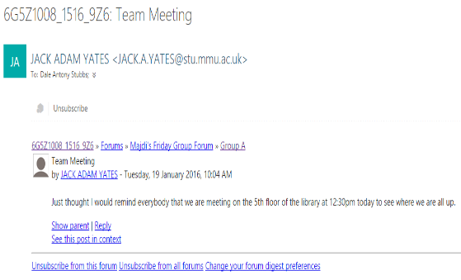The email addresses provided by the University were the single biggest communication tool used online. It was originally the only way that most of the team members were able to communicate with each other and, as such, was an indispensable tool. We were originally instructed NOT to use any form of digital communication (e.g. Facebook Messenger, Skype, Text Message etc.), with the one exception of the forum provided on Moodle, as the tutors had no way to monitor these communications between the team members and therefore every team member subscribed to the forum made available to us on Moodle with their University provided email address. This allowed for every member to read and reply to every other team members’ messages posted within the forum.

*Figure 10.2 an email from a student email account*

### **10.3.2 University Moodle**

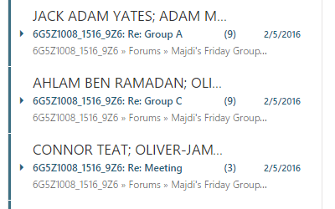The aforementioned Moodle forum provided to us was a great tool for communication however it had one simple but quite large flaw, every team from Madji’s Friday AM lab who subscribed to the forum received notifications from all other pathways. This initiated an influx of messages to each team member from other members of our own team and every other team too. This created a very perplexing arrangement as with each notification followed the opening of an email that potentially had nothing to do with our team. Aside from this flaw the communication via this medium was very good and well maintained by each team member.

*Figure 10.3 messages from multiple teams within one members email inbox.*

### **10.3.3 Team Meetings**

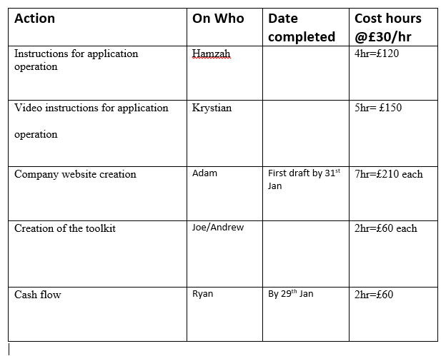Out of all of the communication mediums the team felt that the team meeting were the best form of communication. As mentioned earlier within this chapter all of the predetermined team meetings were very well attended. This allowed every member to effectively state exactly where they were up to within their own topic of the project and what, if any, help was required and from who. It also allowed the finance leader to interrogate the team members in order for him to assign wages for that particular week. A weekly action plan was created every week to allow team members to ensure that they knew exactly what was required of them for any given week.

*Figure 10.4 an example Action Plan*

The minutes that were taken during these meetings also allow for the team to look back to the previous week and to discover if there was anything that needed doing for the current week and to ask if it had been completed (similar to the action plan but with more details).

### **10.3.4 Google Drive**

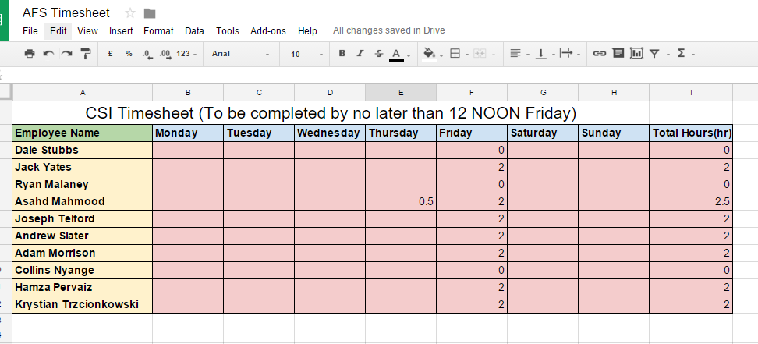I used my personal Google Drive to allow shared access to any files that were required (access granted upon request for the tutors). This tool was very useful when filling out the weekly timesheet for the group. Every member was responsible for putting their own hours onto the timesheet and then proving what they did during the specified hours at the team meeting. If the hours weren’t added to the timesheet by 12 noon on the Friday then no wages were issued in that week.

*Figure 10.5 the company Timesheet*

### **10.4.1 Tasks Completed**

## **10.4 Responsibilities Maintained**

Although one of the tasks went over its original deadline every team member completed their given tasks and the project was completed fully. All of the sub-projects have been completed and merged together to make the final product and a prototype has been created for the purposes of showcasing the product during the upcoming poster event. For a team of ten members it was unthinkable at the start of the project that everyone would get their respective jobs done as there is usually one or two team members that attempt to coast through the task and let everyone else do the work for them. This was not the case within our team, everyone worked together when required to and also pulled their own weight when they needed to push on alone.

### **10.4.2 Deadlines Met**

At the beginning of the project a Gantt chart was created to facilitate in the time management aspect of this project. Each team member was given their tasks based on their roles and deadlines were issued to each task. Only one deadline was missed during this entire project yet, even though this deadline was missed, the action was still completed and had little effect on the subsequent tasks. The project went on to be fully completed by the specified deadline with great success.

## **10.5 Overall Conclusion**

*“There is always strength in numbers. “* (A-Z Quotes, 2016)

The quote above is accurate when it comes to large organisations and items of that scale. The same cannot be said when attempting to organise a very small project like the one we have just completed. Although ten members is not considered a large team it is still incredibly difficult in organising and manipulate a team of this size. However when all is said and done the team did pull together and complete exactly what we originally set out to do and that was to create a new product and to have it ready to be released to the general public and I am proud to say that we have completed that task and completed it well.

# **Bibliography**

A-Z Quotes. (2016). *Mark Shields Quote*. [online] Available at: http://www.azquotes.com/quote/270346 [Accessed 13 Mar. 2016].

Williams, J. (2016). ACPO Good Practice Guide for Digital Evidence. 5th ed. [ebook] p.6. Available at: http://www.digital-detective.net/digital-forensics-documents/ACPO_Good_Practice_Guide_for_Digital_Evidence_v5.pdf [Accessed 13 Mar. 2016].

# **Appendices**

Appendix 2 Year Two Projections

Appendix 1 Year One Projections

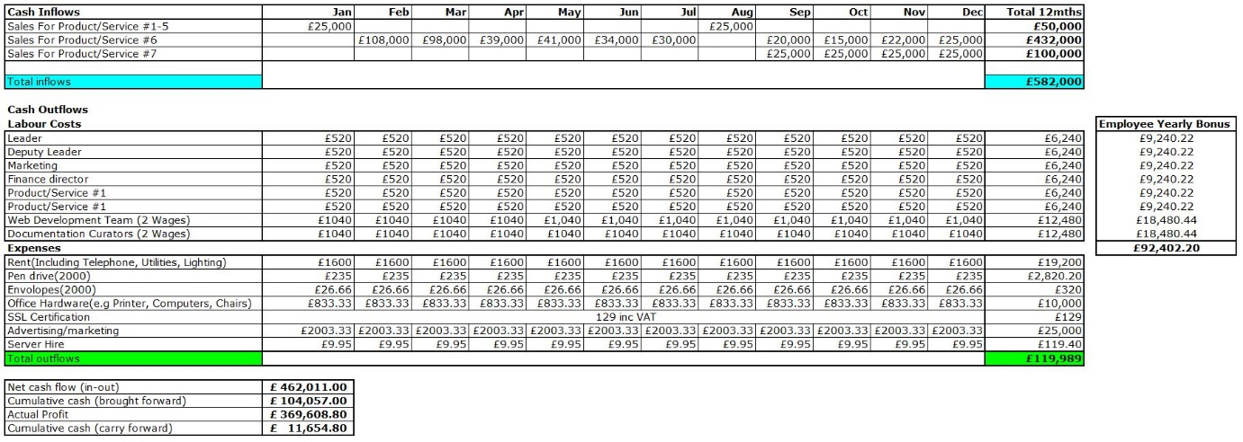

Appendix 3 Year Three Projections